BattleForge Script Trainer

Instroduction:
Tutor: „Hallo I’m TED your Tutor and I will guide you through the BattleForge Script Trainer. I hope you will enjoy our teamwork for the next days.
This document is divided into two parts.
- Basic Knowledge
- Script Guide
When you have mastered these two parts you are able to script a basic mission in BattleForge.
So let us take a look at the index of the Basic Knowledge.”



INDEX of the Basic Knowledge

The script system we use for BattleForge:
- State machine
- States
- Events
- OnOneTimeEvent
- OnEvent
- OnToggleEvent
- OnTimerEvent
- OnRespawnEvent
- OnDeadEvent
- OnIdleGoHomeEvent
- Conditions
- Actions
Tutor: „The next two chapters will show you our tools and the folder- and script structure we use in BattleForge, but for a faster entrance into the world of scripting continue with Script Guide for Single Entities!”

Tools we use for scripting:
- The BattleForge PlugInBased Editor
- Ultra Edit
- GDS Help
- Script Debugger
- BattleForge Config File
- Checked Version of BattleForge

Folders and scripts which we use for BattleForge:
- Folders
- Map Folder
- Camera Folder
- Script Folder 1-3
- Terrain Folder
- UI Folder

- Scripts
- Main Script
- Script Groups
- Script List
- Spawn Groups
- Global Vars
- Difficulties
- Goals
- Outcries
- Entity Scripts
- Accumulative Scripts

Definitions you will need in BattleForge:
Look at: Glossary.docx

Tutor: „The Basic Knowledge is a kind of reference you will need the whole time during you work with the BattleForge Script Trainer and when you are scripting your own BattleForge map. The second part is the Script Guide. Let us take a look at the index there too.”

INDEX of the Script Guide

Script Guide for Single Entities:
- Create an Entity
- SquadSpawn and Respawn
- AbilitySpawn
- BuildingSpawn and Respawn
- ObjectSpawn and Respawn

- Modify Entity
- AbilityAdd and Remove
- Health Add and Set
- Spell Add and Cast
- Team and Player Set
- Type Change
- Effect Start and Stop, Enable and Disable

- Move Entity
- Squad Goto
- SquadGridGoto
- SquadPatrol
- SquadGridPatrol

Script Guide for Entity Groups:
- Create a Script Group
- SquadSpawn into Group
- AbilitySpawn into Group

- Modify Groups
- AbilityAdd and Remove
- Health Add and Set
- Spell Add and Cast
- Team and Player Set
- Type Change
- Effect Start and Stop, Enable and Disable

- Move Group
- SquadGroupCheckpointGoto and Stop
- Warfare Pattern

Script Guide for the User Interface in BattleForge:
- Mission Task
- Mission Counter
- Mission Timer

Script Guide for the Balancing in BattleForge:
- Squad Balancing
- Starting Power
- Mission Difficulties
Tutor: „With the Script Guide you will learn how to script special situations first for single Entities (Units, Squads, Buildings, Objects, Abilities, Effects) and after that for Groups (A Group is at least two single entities). Also you will learn something about the User Interface and how you can balance your map.

Basic Knowledge

The Script system in BattleForge:

State machine
We use the LUA scripting language for mission scripts. Every Script is executed when the map is loaded and the Script system written in LUA translates the meta-scripts to actual C++ objects and builds the script state machines. That means that the LUA scripts you work with do not actually run during the game but are converted to game logic when the map is initialized.
Normally you will not need to know much about LUA itself because we have built a meta-language (GDS) on top of it, whose main building blocks are States, Events and Conditions and Actions. However it does help to know that you can still use loops & conditions constructs from LUA to generate these building blocks, which can make scripting easier but also, if you are not careful, can make scripts harder to read and understand for others.
Our GDS scripts tend to favor lots of copy & paste actions which is relatively easy to do and comes natural for beginners. However, scripts that rely heavily on copy & paste are hard to maintain and debug. So if you happen to notice that you do a lot of copy & paste, let us know right away, so that we can discuss ways to improve the script and find solutions which are more stable and easier to extend and maintain. Also, from time to time you will come across a problem that may as well affect other scripters and then it may be a good time to develop a general solution and make it available to all scripters.

Scripts and their Layers
A script usually consists of three different layers. The first layer is the "State", of which there can be many. Only "Events" that are in the currently active State are checked. The script is always in one of those states (and never in none or more than one).
A State consists of "Events", which are the second layer. Events themselves consist of "Conditions and Actions", which are both part of the third layer. In the picture below you can see how the actions and conditions are part of the event, and how the event itself is part of a state.

EXAMPLE:
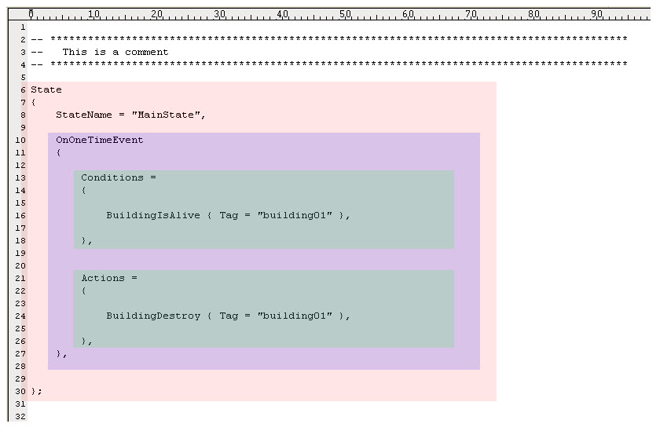
A real script might look like the example shown in the picture below. Notice the state, events and the condition/action layers.
EXAMPLE: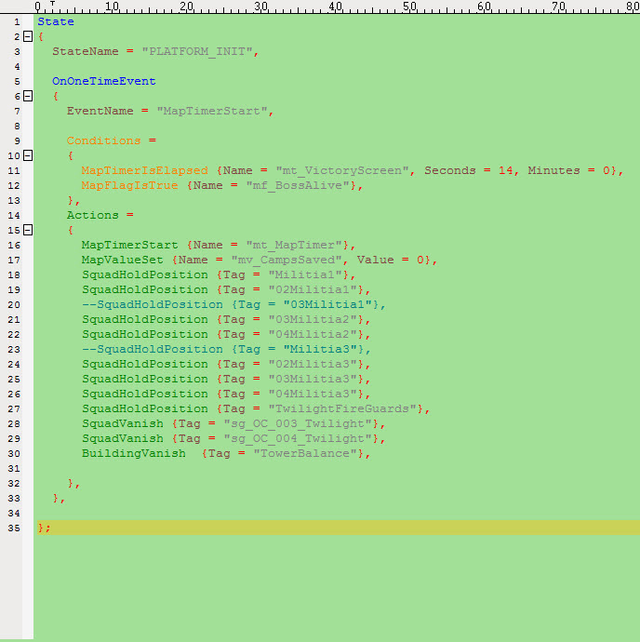

States
Until now we have worked with scripts that consist of only one state. As our scripts conceive so-called "state machines" they can have many states.
What does that mean?
A state machine is always in one state, it is never in two states or in no state. It can change its state.
In our scripts, the states are containers for events.
Only those events are checked which are in the active state.
See the picture below:
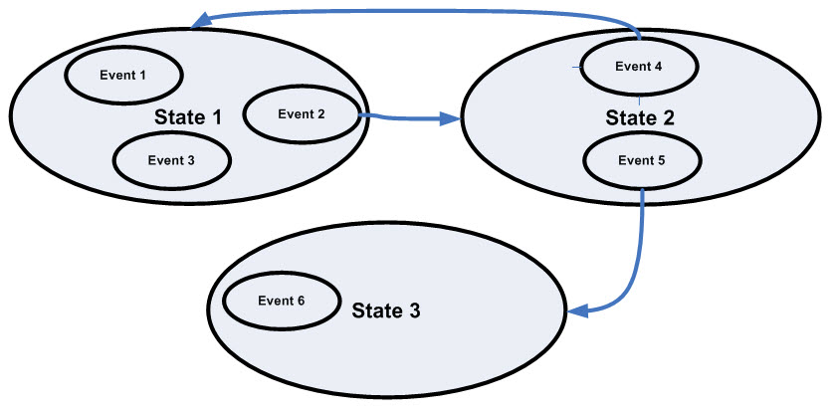
In the example script there are 3 states, each containing different events.
When a script is executed, the first state in the file becomes active (here: state 1). In state 1 there are the events 1,2 and 3 - which means that as long as the script is in state 1, only the events 1,2 and 3 are checked (their condition blocks are checked) and can be executed (the actions blocks are executed if conditions are true).
There are also transitions between states: For example if the script is in state 2, and the event 4 is executed, the script changes into state 1. Only state located in the same file can inter-connect. It is not possible to refer to a state located in another file.

Why to use states?
Using states is a natural way to break down large task in smaller logical segments, and has several benefits:
- Using states is generally good for performance & memory usage (fewer conditions need to be checked at any one time) If you have a script with 1 state containing 50 events, the condition blocks of all of these events have to be checked permanently. If you have a script with 10 states containing 5 events each instead, only 5 events have to be checked permanently.
- Performance is one of our top-critical issues - so use states to keep performance high.
- Using states makes scripts easier to debug (you know where you are when something goes wrong, you can avoid a lot of undesired side-effects, you need to use less "state" variables)
- Using states generally results in fewer conditions (no need to recheck conditions from events in previous states), thus making scripts easier to understand
- Scripts with states are easier to maintain and extend
Note: try to avoid creating too many inter-connected states. From experience most scripts can be divided into states in a very simple (often linear) fashion. Mostly the flow of States in a script goes primarily from top to bottom. Some scripts need to loop and thus later states connect to an earlier State, that is ok too. But if you have many states connecting to each other there's a good chance that you should rather be using one bigger state, or multiple scripts, or a completely different approach altogether. Good indicators for too many interconnected states are lots of connections in different places either going "up" or "down" in the script, and mostly connecting states far from the current (and surrounding) states. If it is even hard for yourself to follow the flow of State connections, then there's definetely room for improvement in your script logic.

When to use states?
If things happen in a linear order.
Example:
- Orc Marauder patrols at the hut from 9:00 a.m. to 12:00 noon, stands in front of the cave from 12:00 noon til 3:00 p.m. and strolls through the mountains between 3:00 p.m. and 9:00 a.m.
In this case, one would have three states - one for each of the three time periods.

- 09:00am - 12:00pm
- 12:00pm - 03:00pm
- 03:00pm - 09:00am

- Goblin Maiden is hidden in a cave at the beginning of the map. As soon as the player finds the magic key, she leaves the cave and wanders through the hills. When the player has destroyed the evil castle, she tracks him down, turns hostile and attacks him. (They player is not able to destroy the evil castle before he found the magic key.) There should be be the following states:

- "before key is found
- "after key is found and before castle is destroyed
- "after castle has been destroyed".

How to use states?
Every state has a StateName. If you want a script to move into a different state, you need the GotoState command. This is linked to an event and it is only executed if the conditions of this event is true - but it is NOT put into the actions block of that event.
A minimum version might look like this:

EXAMPLE:
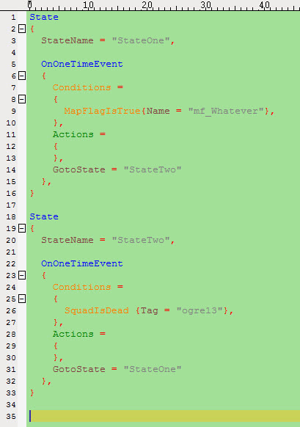

Events
There are a lot of different types of events:
- OnEvent
- OnOneTimeEvent
- OnToggleEvent
- OnTimerEvent
- OnRespawnEvent
- OnDeadEvent
- OnIdleGoHomeEvent

OnEvent
An OnEvent executes its actions every time when its conditions block is true.
As events are checked 10 times a second, this could mean that an event is executed 10times a second if the conditions block stays "true" the whole time (which would lead to the problem that no other events of the same script are executed and that the whole game might be dragged down).
So the conditions block of an OnEvent must be written in a way, that it is not permanently true.
EXAMPLE:
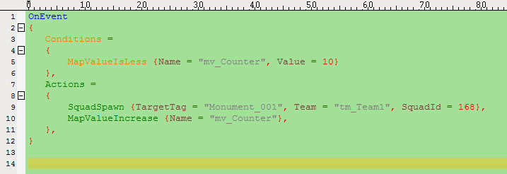
In this example, the event checks if the value "mv_Counter" is less 10. If so, it spawns a squad with the Id 168 and raises "mv_Counter".
So as the map value in the beginning is 0, the script will spawn 10 squads for Team1 at "Monument_001" and then the event will not trigger any more.
If the line:

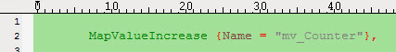
or the condition would be missing, the script would completely spam the map with squads - and the script would drag down the whole game.

OnOneTimeEvent
An OnOneTimeEvent is an OnEvent that is executed only one single time.
There is a hidden flag attached to that event, that is checked in the conditions block and set true when executed for the first time. For security reasons you normally should use OnOneTimeEvent. Only if you need an event being executed several times you should use an OnEvent.

OnToggleEvent
Toggle events are another type of event. This event can be "on" or "off" and can toggle between those two phases.
So it has not only one condition block and one action block, but two: it has an OnConditions-Block and an OffConditions-Block, and it has an OnActions-Block and an OffActions-Block.
From the beginning the event is "off". If the event is "off", it only checks the conditions of the OnConditions-Block. If this condition block gets true, it executes the OnActions and turns "on".
If the event is "on", it only checks the conditions of the OffConditions-Block. If this condition block gets true, it executes the OffActions and turns "off".

EXAMPLE:
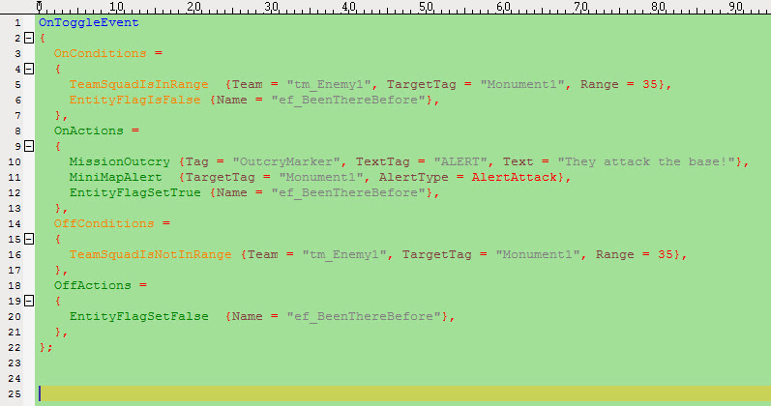
In this example a mission outcry is triggered everytime an enemy units comes into range of 35 meters to the player's 'Monument1'.

Complementary condition blocks
Very often scripters want the OnConditions-Block and the OffConditionsBlock to be logically completely complementary (which has a lot of advantages). Sometimes if an condition block is very complex, it seems hard to find the complementary conditions. In fact it's really easy to find them: You just have to negate the boolean operator on the top level.
Let's look at two examples:
EXAMPLE:
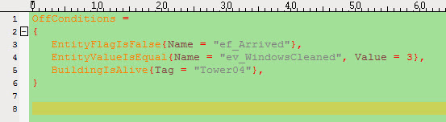
In this example, there is no explicit boolean operator. This means that the conditions are connected by an AND operator.
To find a complementary condition block, you just turn it into NotAND:
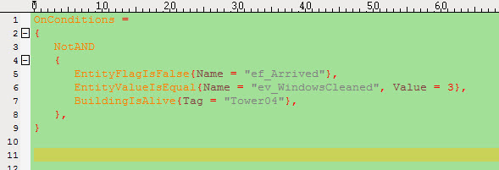

Empty action blocks
Scripters seem often restrict themselves to use OnToggleEvents only if they have actions to be executed in "Off" and "On". But there's also the possibility that you leave one of the action blocks empty. Why could that be useful? Let's look at an example:
EXAMPLE:
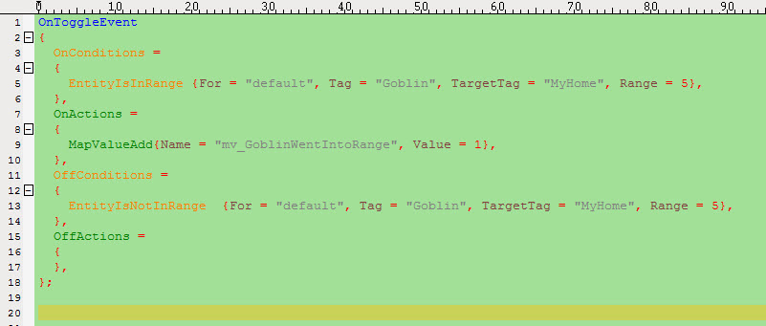
As you can notice, the OffActions block is empty. What does the event do? It increases a counter every time, the unit "Goblin" comes into a range 5 meters to the position 'MyHome'. But due to the toggle event, it does not permanently increase this counter when the "Goblin" stays within this range. The counter is only increased, when the "Goblin" leaves the range (so the event toggles from "on" to "off") and then re-enters the range again (so the event toggles from "off" to "on").

OnTimerEvent
OnTimerEvents are a more comfortable way of using timer actions and conditions. They enable you to set conditions for when to first start the timer, and which actions to execute, as well as the conditions for every execution starting with the second, and its respective actions. As well, you may enter a minimum time until the 2nd execution happens.

EXAMPLE:
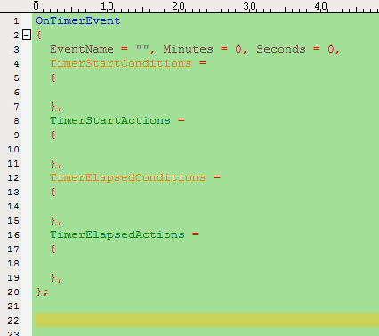

OnRespawnEvent
IMPORTANT: This event is only working in Member Scripts of units and squads. It doesn't work in the Main script.
When a creature appears in the game out of nowhere, we call this "spawning".
When a creature was killed and later re-appears again, we call this "respawning".
When units will be killed, their Member Scripts will be executed too . But there are exceptions: The OnRespawnEvent, and the OnDeadEvent.
If a unit was killed, it keeps on checking the conditions of its respawn event - but only if this respawn event is in the state the unit was in when it was killed.
If the conditions of the respawn event become true, the unit re-appears again in the game (with full health and mana). There are additional parameters like TargetTag and RespawnDelay.

EXAMPLE:
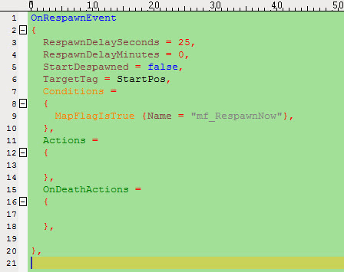
If you want that a unit is not on the map right from the beginning, but that it only will appear as soon as some conditions are true, then use the parameter "StartDespawned = true": The unit will spawn only when the conditions are true.
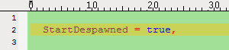
Well ... at least this is how it seems to the player. Technically, things are a little bit different: Technically when the map starts, the unit appears - but is killed in the first frame. So you don't notice the unit was there. Please also note, that as long as the unit was not spawned, it is seen as "dead" by the script. If you do a "SquadIsDead" condition on this unit, and the unit did not spawn yet, you will receive a "true" answer.

OnDeadEvent
IMPORTANT: This event is only working in Member Scripts of units and squads. It doesn't work in the Main script. This event is only executed if and when:
- the unit dies in the State that contains the DeadEvent
- there is a RespawnEvent in that state
- the conditions of the DeadEvent are TRUE

EXAMPLE:
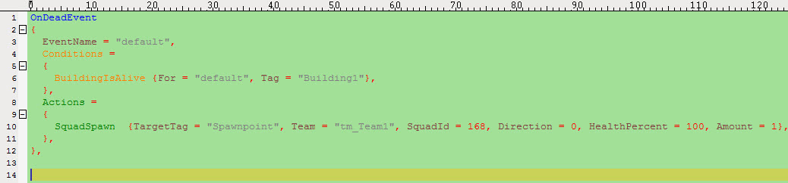

OnIdleGoHomeEvent
If units are not in range of a hostile unit which would draw them into combat and also do not have any task to fulfil (like a "goto" command), for code they are "idle".
The event "OnIdleGoHome" send units that are idle back to their homepoint (as long as the condition block delivers TRUE). The homepoint is defined by the TargetTag. If this Event is called in an entity-script, the "Tag" parameter can be left out: it automatically gets the name of the entity, to which the script belongs.
Please note: The "OnIdleGoHome" does not mean that the unit won't run to an enemy when it sees one. It just means that the unit will come back to its homepoint after it killed the enemy.
EXAMPLE:
Why is this useful?
- This is a way to control where a unit is.
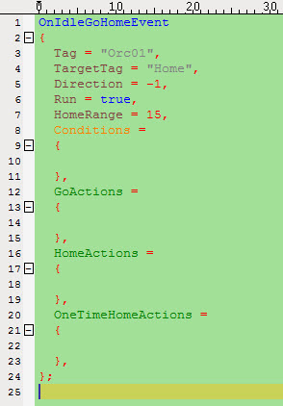
- If you don't have it, a unit can be dragged away by enemies. For example: Unit sees an enemy, runs to it, kills it, sees the next enemy, kills it, sees the next enemy ... and so is dragged over the whole map.
- If you don't have it, a unit just could be moved from its place by swapping it away. You could swap it over nearly the whole map.
- So if you want the orc always to stay near its home (as long as the orc is not in combat), use the "OnIdleGoHome" command.
The unit will try to go to its homepoint, as long as
- the conditions of the event are true
- the unit is idle
- it is not at its homepoint.

EXAMPLE:

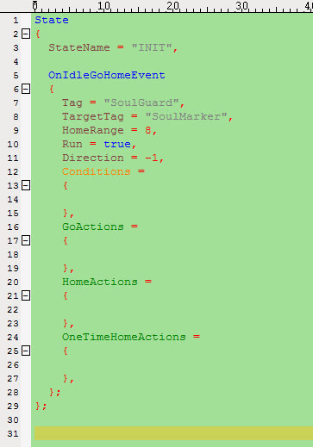
In this example the unit 'Soulguard' will return to its homepoint 'SoulMarker' if it is idle and further away than 8 meters.

More parameters: HomeActions / OneTimeHomeActions
Every time the unit returns to its homepoint by executing OnIdleGoHome, it executes its HomeActions.
This is a thing to remember (because it gets easily forgotten and can lead to bugs): Even if an unit with an OnIdleGoHome is only swapped away for one gridpoint and then returns to its homepoint, these actions are executed.
If you want actions that are only executed one single time, you should use OneTimeHomeActions: These actions are only executed, when the unit comes to the point for the very first time.

EXAMPLE:
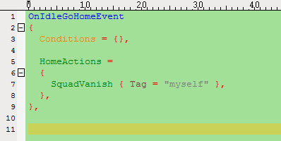

Conditions and Actions
Conditions and Actions have to be inside an Event-Block.
We would like to make sure that the player is under attack at all times. We do not want to overwhelm him by spawning enemies all the time. It sounds ok to have new enemies spawn once the last wave has been defeated.
Event: "No more enemies around, so spawn new troops"
Once the condition is true, the action is executed.
Condition: "No more enemies alive?"
Action: "Spawn enemy troops"
Find out what is the condition and what's the action in the following examples:
- "As soon as the ogre reaches the captain, the captain will scream 'Bloody hell'".
- "Finally the orc king has only 30% hitpoints left. He turns around and flees in terror."

Conditions
You can find a list of all currently available conditions in the Script Help Tool (_run.bat).
The following are a few conditions from the Battleforge Script Engine and their meanings.
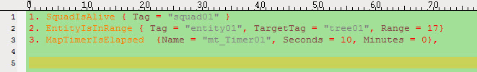
- Checks if the squad called "squad01" (the tag has been set in the editor) is alive at the moment.
- Checks if an entity called "entity01" is within range of 17 meters to the object "tree01".
- Checks if 10 seconds have passed since the MapTimer "mt_Timer01" was started.

Tutor: „A word of warning:
Events with an empty conditions block are executed immediately. This is especially bad in combination with "OnEvent" - events, meaning that the actions of that event would be executed non-stop. Performance would suffer badly.“
”

Actions
You can find a list of all currently available actions in the Script Help Tool (_run.bat). The following are a few actions from the Battleforge Script Engine and their meanings.
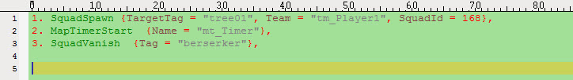
- This action spawns a squad at the object "tree01". The squad belongs to Player1 and has the ID "168" in the editor/BEE. The IDs can be checked in the BEE or the editor (BEE is preferable).
- Starts a MapTimer called "mt_Timer".
- This causes the squad, in that case with the scripttag "berserker", to vanish, meaning it dies without playing the usual death animation.
Tutor: „ There can be more than one action in an action block!
Write the second action beneath the first and end the line with a comma and so on. As many as you want, but watch out for your script performance!”

Multiple conditions and boolean operators in the conditions block

Having more than one condition
Just as there can be more than one action per block, there may be multiple conditions as well. Those multiple conditions can be combined in a number of ways. A few examples are:
"Are both (or all) conditions true?"
That is called "AND" in boolean logic. It could as well be rephrased to "Is at least ONE condition false?"
"Is at least ONE condition true?"
That is called "OR" in boolean logic. It could as well be rephrased to "Are not all conditions false?"
"Is only one of two conditions true?"
That is called an "XOR", or "exclusive or", in boolean logic. It could as well be rephrased to "Are not both conditions true or false?"
EXAMPLE:
"Kruul, the orc warriorking, will only talk to the player if he has destroyed both the golem and defeated the dragon." There are two conditions here:
"Has the player destroyed the golem?" AND "Has the player defeated the dragon?"
Only if both are true, Kruul will talk to the player. In a condition block, it could look like that:
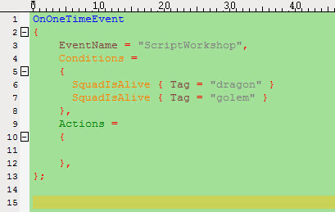
As seen, there are no ORs or ANDs anywhere. That is because the Script Engine automatically assumes that all conditions are to be true, so adding "AND"s would have changed nothing here. But if you like, you could write it as follows anyway:
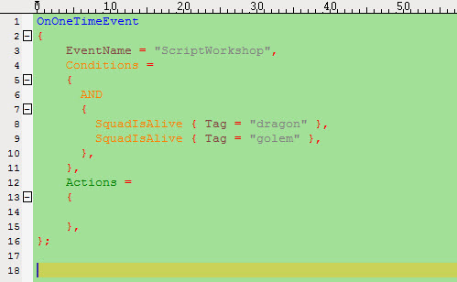
In that case it is explicitly checked if both conditions are true. Think of the "AND" as being a condition as well. One that is only true if its sub-conditions are all true.
Now let's assume that Kruul is in a good mood today, so he will talk to the player as long as at least ONE of the two monsters have been slain. That means that combining the two conditions by "OR" would do the trick. Since the Script Engine automatically assumes an "AND", in that case you have to write the "OR" or it won't work.
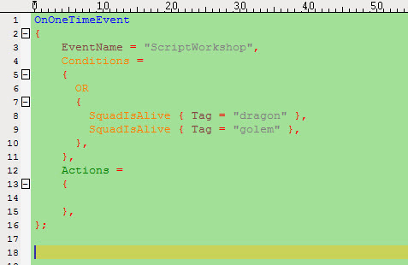
Now for the OR-block to be true, it would be sufficient for one of the two conditions to be true.
Tutor: „Now you will learn which tools we need for the scripting in BattleForge. For a faster entrance into the world of scripting in BattleForge continue with Script Guide for Single Entities!”

Tools we use for scripting

The PlugInBased Editor

Documentation see link below:
BattleForge LplugInBased Editor Manual
Important script relevant topics when you work with the PlugInBased Editor:

Team Setup & Player Kits
Something very important is the Team Setup window in the Editor. It is located under:
Map Settings/Team Setup & Player Kits
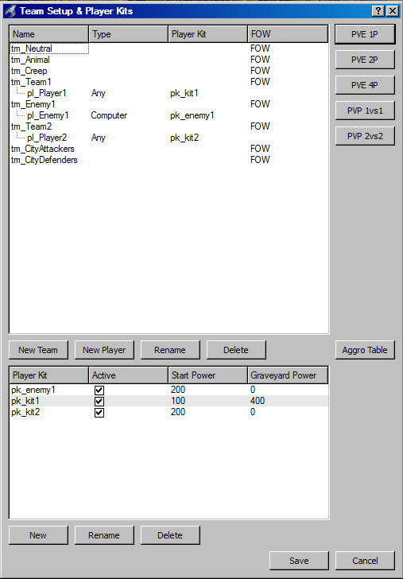
Here you can adjust the human player and the computer enemy.
IMPORTANT:
Each Player needs a Team. A Team is able to includes one or more players. A player can use Playerkits.
The Team is important for the Aggro Table. Here you can adjust how the team reacts with other teams (friendly, neutral or hostile).

At the Player setup you can choose three different Types:
- Any
- Human
- Computer.
For human players use any for computer opponents use computer.
With the Playerkit you can allocate Start/Graveyard Power to a player before the game starts. The human player needs power to play his cards. Graveyard Power is the power the player will earn after a specific time is elapsed.
Next to the Player kit you can adjust the FOW (Fog Of War). You can use three different settings:
- No FOW (the mini map is absolutely clear no black and no fog)
- Unexplored (everywhere a human player unit was, the mini map is clear, without fog)
- FOW (everywhere a human player unit was, the mini map cover this area with fog)
Use the buttons on the right site to choose the right game mode:
PVE 1P Single Player Campaign
PVE 2P Coop two Player Campaign
PVE 4P Coop four Player Campaign
PVP 1vs1 one Player versus one Player
PVP 2vs2 two Player versus two Player
Tutor: „ Give the teams and the players useful names. Watch out for the prefixes. A team name have to start with tm_ . A player name have to start with pl_ and a player kit starts always with pk_ . In this chapter you learned how to adjust the team and player settings in the PlugInBased Editor.”

Entity Placement

It is located under: Windows/Entity Placement
The Entity Placement is divided into:
- Squads
- Buildings
- Objects
- Misc
- Power Slots
- Token Slots
- Fortification
- Effect
The start position of the human player you can define by placing a “Starting Point” at the editor map. You will find it under Misc.
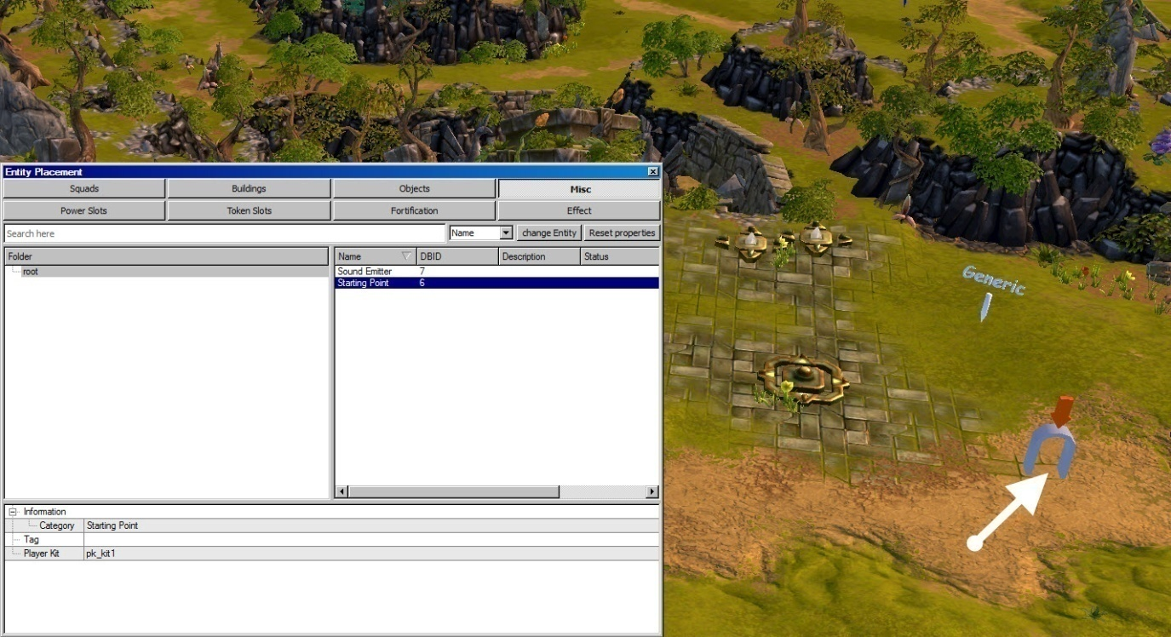
The player also needs a token/monument and some power slots to start with a map. Therefore chose a “TokenNormal” under token slots and “PvE 600” under power slots and place them on the map.
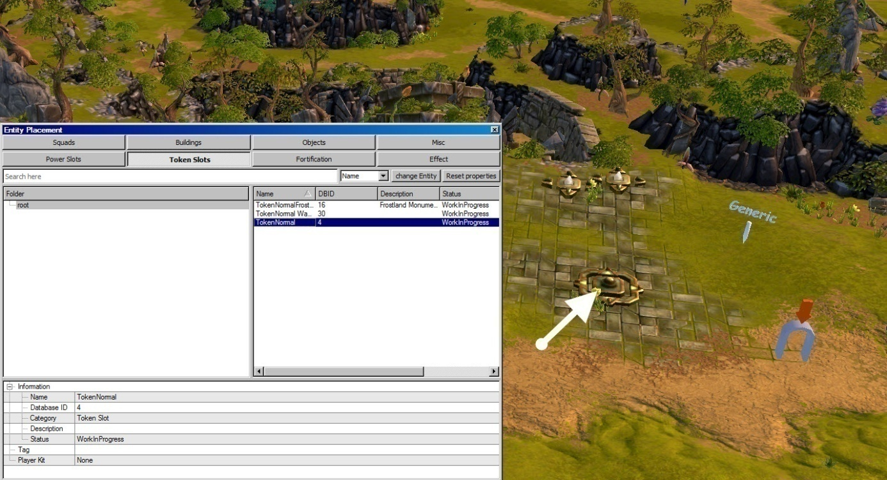
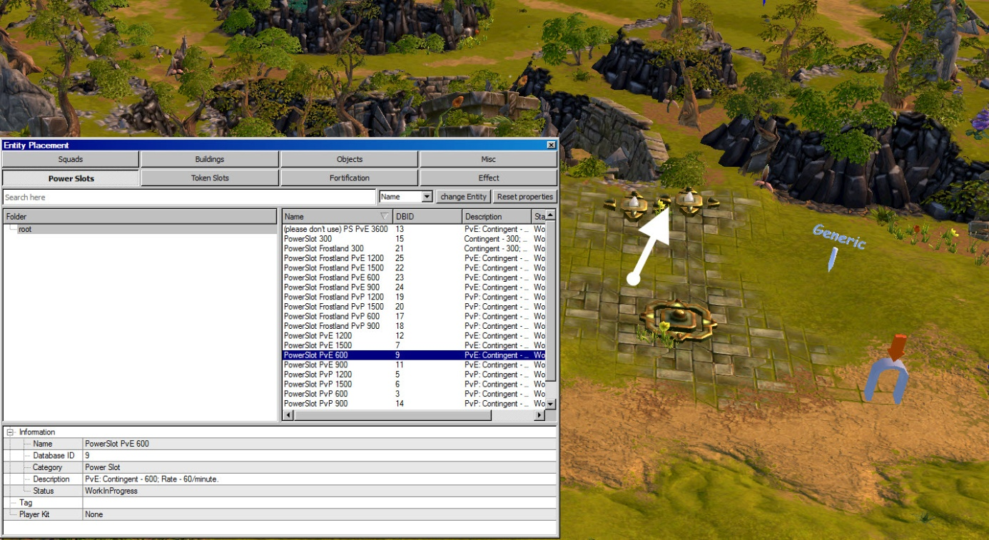
We usually give the human player one token and two PvE 600 power slots. After you have place them choose the right team setup for this objects. Therefore you have to open the “Entity Property” under windows and to select the entity (token/power/starting point)
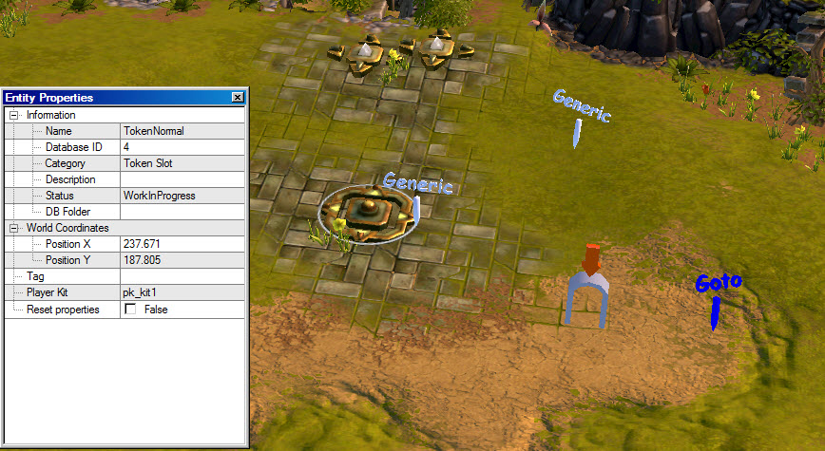
On the picture at the top you will see the entity properties window for the token/monument. It shows you the x,y position, the database name, the script name TAG and the player kit. To assign the token to the human player you have to change the player kit into the player kit of the human player, you have used in the Team Set & Player Kits window. Use this method for the power slots and for the starting point.

Tutor: „Remember: For each map you build and for each human player on these maps you need one starting point, at least one token/monument and two PvE 600 power slots. In this chapter you learned how to prepare your map in the editor for all your human players. ”

Ultra Edit

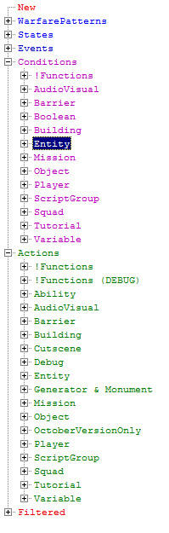
At the moment we use Ultra Edit – 32 Professional Text/HEX Editor Version 13.20+1
http://www.ultraedit.com/
Check out the configuration of Ultra Edit:
Ultra Edit Configuration Doc

GDS Help
D:\project\battleforge\main\tool\tool_GdsHelp\_run.bat
The GDS Help is our script library. Here you will find any commands you needed for your scripting.
The GDS is divided into three parts:
- The Library
- The Syntax
- The Help
At the library you will have a list with all of your commands you can use for BattleForge. The library is divided into:
- Warfare Patterns (blue)
- States (blue)
- Events (blue)
- Conditions (Purple)
- Actions (Green)
Below the library you will find a filter search, where you can search filtered commands.

Part II is the syntax part. When you click on one command at the library, the whole syntax of the command will appear at this window.
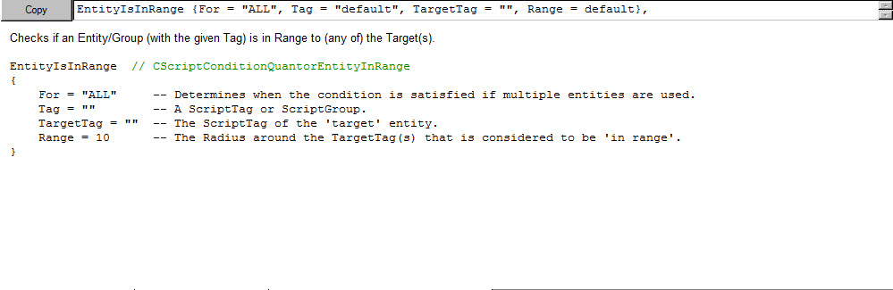
At the first line you can copy the command and paste it into your script file in Ultra Edit. Below the first line, you will see the command in a more comfortable mode. You will see all parameters among each other for a better understanding.

The last part is to explain the command with words from the owner.
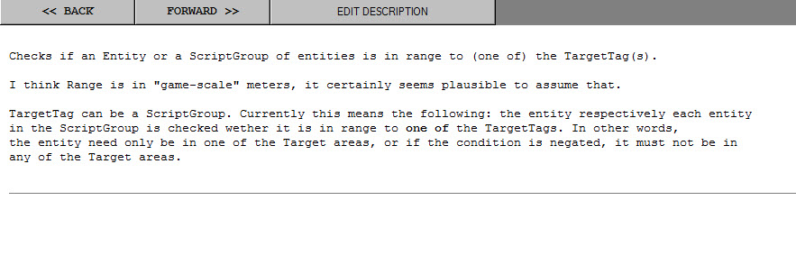

Script Debugger

D:\project\battleforge\main\tool\bin\ScriptDebugger\ScriptDebugger.exe
With the Script Debugger you have the opportunities to follow single States, Events, Variables, Timers and Flags during the game.
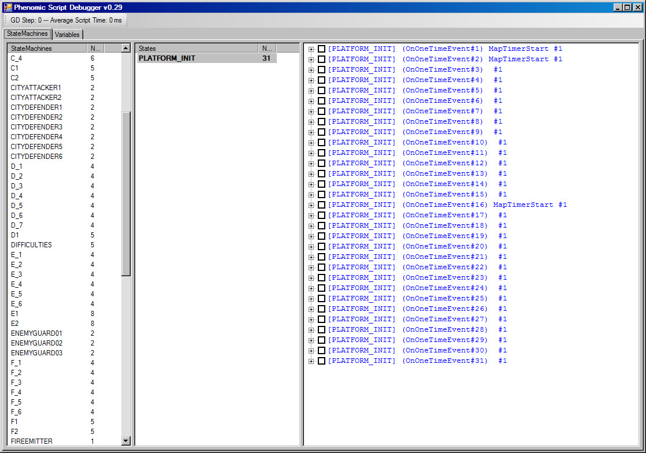

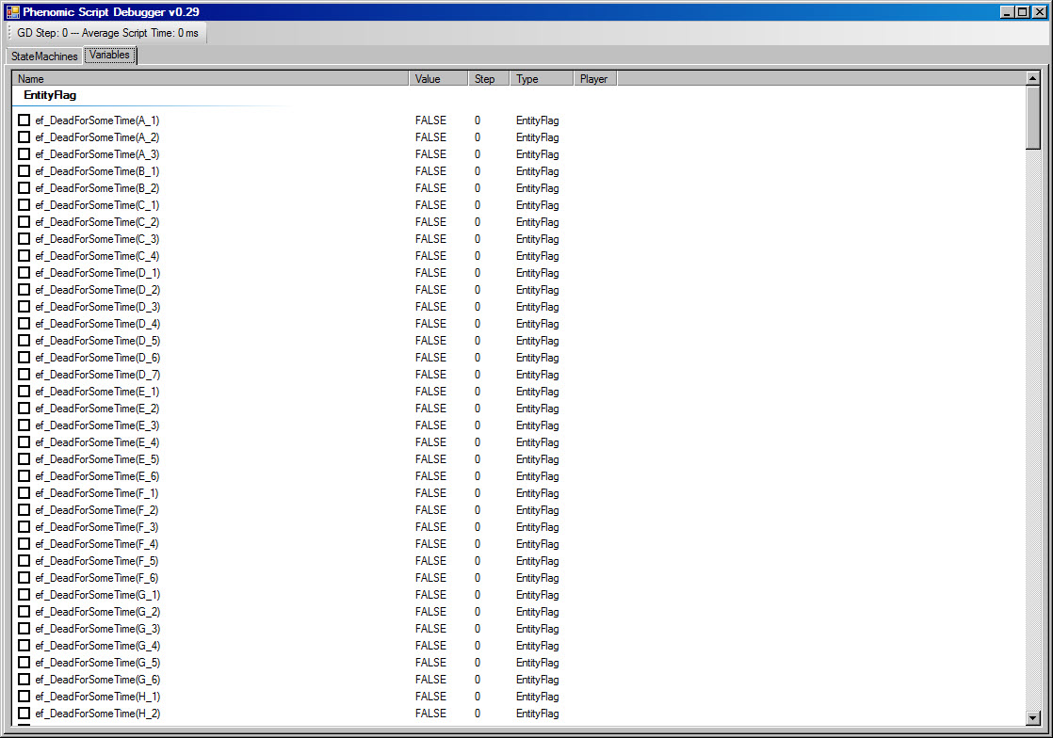

BattleForge Config File
In Battleforge's config file you have the possibility to change some configurations for the game and the editor. The file can be found on drive "C", in your personal folder under "Documents". Here the most important configuration tags for level designers:
filtermaxdistance is the distance from the camera in which objecs are rendered in the game and in the Editor. It should be set about to 2000.
fullscreen: if set to 1 Battleforge runs under fullscreen mode, if set to 0 it runs in windowed mode.
screenheight,screenwidth: resolution
Difficulties: 0 = standard, 1 = advanced, 2 = expert
A documentation about the config file you can find at
BattleForge Config Doc

Checked Version of BattleForge

To test your maps you have to use the "battleforge_checked_dll.exe" located in the "\Project\battleforge\main\redist" folder. In the Main menu choose PvE/PvP or Test Maps to get a list of all ".map" files located in the PvE/PvP or test-directory, which is
"\project\battleforge\main\redist\bf1\map\PvE,PvP,test".
This is the folder in which Script Workshop scripts are written.
Default Settings: If you restart Battleforge and you want to test the same map as you did the last time, you can just click Default Settings in the Mainmenu and the map is loaded.

Reload Map: You don't have to return to the Mainmenu every time you want to restart your map. Just click at Restart Map on the left side of the ingame screen.

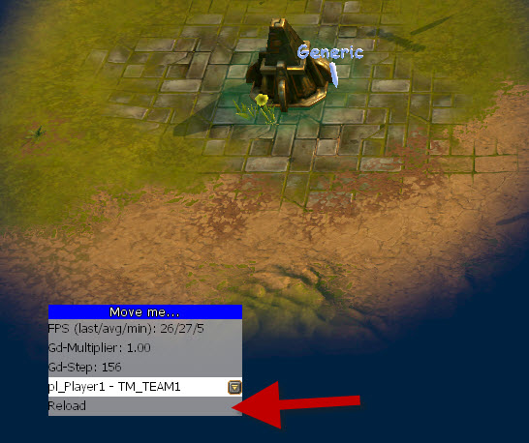
Debug: While playing your map, you can get useful information by pressing the y key. It turns on some debug informations. The main cathegories can the be switched with x and c and the subcathegories with v and b.
Speed: You can speedup the game with the Numpad keys 1-9.
There are several cheats to increase the testing efficiency available at:
BattleForge Cheats
Tutor: „ For a faster entrance into the world of scripting in BattleForge continue with Script Guide for Single Entities!”

Folder Structure in BattleForge

In general we save our scripts and maps into following folders:
D:\project\battleforge\main\redist\bf1\map
- PvE
- PvP
- Test
PvE for single player or coop campaign maps.
PvP for player versus player maps.
Test for the workshop or script tests.
To test your scripting you need a _.map file and a folder with the same name, for example:
EXAMPLE: 11100_PvE_01p_SiegeOfHope Folder
EXAMPLE: 11100_PvE_01p_SiegeOfHope.map
First Release, First Single Player Campaign Map, Map name
The map folder includes:
- Camera Folder
- Script1
- Script2
- Script3
- Terrain
- UI

Camera Folder
The camera folder includes tracking shots from the cutscene tool.

Script1-3
These are the folders where you save your Lua script files, which you generate in Ultra Edit. It depends of the mission design but generally you will use up to 70 single scripts. For the script performance you have three folders where you can divide your single scripts. Script folder 1 is the most important one. Here you will find the main scripts.

Terrain
In the terrain folder all the textures from the map will be saved. The color, the normal textures and the normal patches you will find here.

UI
In the UI folder you will find the minimap of the map. It is always named as minimap.jpg .

These are the different single script files in BattleForge

Main Script
The Main Script is the most important single script file in BattleForge. This is also the first script which will be read from the interpreter. It contains general y the starting conditions. To declare a single script Lua file as a main file you have to use “_” as a prefix and after that, the complete name of the map folder, for example:
EXAMPLE: _11100_PvE_01p_SiegeOfHope.lua

Script Group

Declaration
You need a single Script Group declaration file when you want to merge a few single Entities into one group. In this file you declare all your Script Groups you will use on the map. The syntax for the Script Group Declaration file is:
EXAMPLE: _11100_PvE_01p_SiegeOfHope_ScriptGroups
The syntax in the Script Group file you will see below:
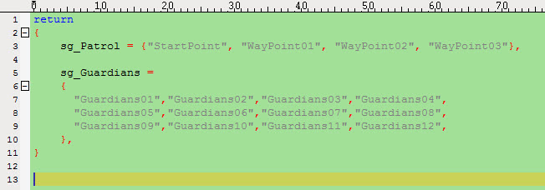
Line 3: sg_Patrol (Prefix sg_ is important) is a script group with four way points. You can use this script group in a patrol command.
Line 5: sg_Guardians is a script group with 12 named units. You can use both notations.

Script Group file

If you want to use one Script file for the whole group and each member you have to use the ScriptGroup file. The syntax for the Script Group file is:
EXAMPLE: sg_Patrol (The name you used in the Declaration) or sg_Guardians

Member Scripts

When you will use an on respawn event or an on idle go home event for each member of a group you have to implement a Member Script. With a Member Script the respwan will start for each group member exactly after it dies. When you choose the respawn in a script group file it doesn’t work! The syntax for the Member Script is:
EXAMPLE: sg_Guardians_Member

Important: To use a Member Script you need mandatory a Script Group file. The Script Group file could be empty.

Script List
To start other single scripts which are not a Main-, Memberscripts, Script lists, Spawngroups,GlobalVars or Script Groups than you have to call it up in the Script List. The Syntax of the Script List is:
EXAMPLE: _11100_PvE_01p_SiegeOfHope_ScriptList
The Syntax in the Script List file you will see below:
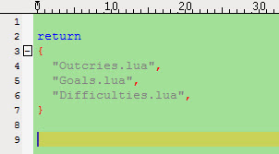
In Line 4-6 you have to write your additional single .lua files.

Spawngroups
This is a special kind of scripts which will support enemy unit/squad spawning. The Syntax of this Script is:
EXAMPLE: _SpawnGroups
The Syntax in the SpawnGroup file you will see below:
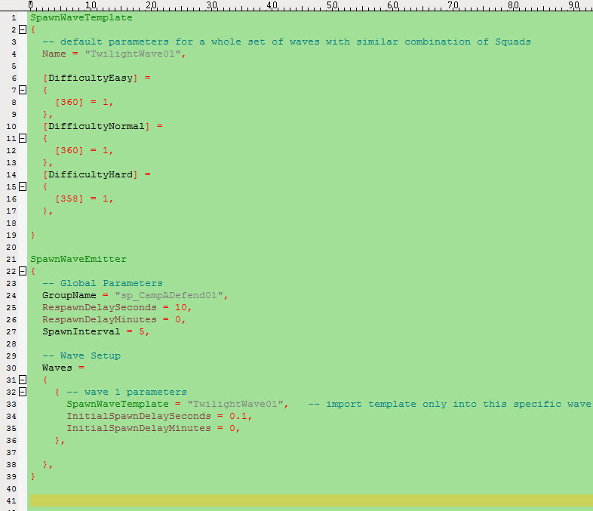
At the SpawnWaveTemplate you will insert the unit/squad ID and the amount for the three difficulties (easy = standard, normal = advanced and hard = expert)
At the SpawnWaveEmitter you will insert the SpawnWaveTemplate, because you can have more than one. Additionally you can adjust all the time relevant parameters.

You can use more than one Template or more than one Wave. Look at the following example:

EXAMPLE:
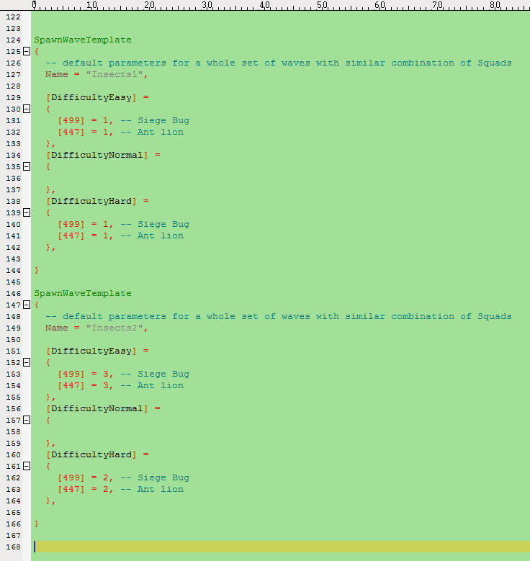
Here you see two SpawnWaveTemplates: Insects1 and Insects2. Insects 2 has a much stronger wave than Insects1. In difficulty Standard (Easy) at Insects2, there is the count of the squads three times as much as at Insects1 and in difficulty Expert (Hard) there will be 5 Siege Bugs [499] and 5 Ant lions [447] at Insects2 and only 2 Siege Bugs and 2 Ant lions at Insects1.

EXAMPLE:
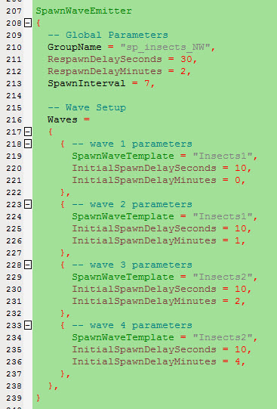
Here you see an example of a SpawnWaveEmitter with four waves. When all squads of all four waves are dead, they will respawn after 2 minutes and 30 seconds. Than the first wave of the template “Insects1” will appear after 1 minute and 10 seconds the second wave of template “Insects1” will appear, after another 2 minutes and 10 seconds the third wave of template “Insects2” and at least the fourth wave of the template “Insects2”.
In additional to the _SpawnGroup file you need a single script file with the WP_SpawnWave command. This files are named: With the GroupName of the SpawnWaveEmitter
EXAMPLE: sp_CampADefend01

Global Variable
Global variable you can create at each script but it will be more clearly arranged when you use a special kind of script. The Syntax of the script you can see below:

EXAMPLE: _GlobalVars

Difficulties
In BattleForge there will be 3 difficulties:
- Standard (former easy)
- Advanced (former normal)
- Expert (former hard)
For a good script overview we use one special script. The Syntax of this single script file is:
EXAMPLE: Difficulties
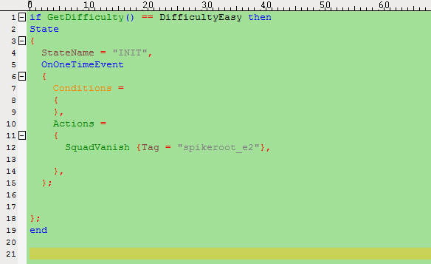
Line 1: Lua (if, then) script command
Line 2: New state starts but only when the difficulty is easy (Standard)
Line 12: When the difficulty is easy (Standard) the heavy unit “spikeroot_e2” will be vanished from the map.
Line 19: The Lua (if, then) command ends (Don’t forget this end!)
You can use the script file for all three difficulties. You only have to make three states with three different conditions. Start with the next difficulty below Line 20.

Goals
In this script we are writing all goals for all players. It also supports a better overview.
The Syntax is:
EXAMPLE: Goals
Generally the Game Won/Game Lost conditions and actions will be written in the Goals script file too.
EXAMPLE:
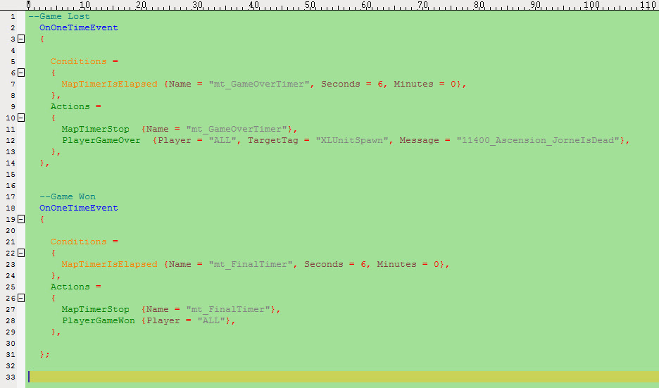
Line 12: Here you will see the Game Lost command. Player All = every player lost the game. TargetTag = The position where the camera is linked Message = Description why they lost.
Line 28: Here you will see the Game Won command. Player All = Every player win.
You have to include the Script into the Script List like the Difficulties.

Outcries
In this script all outcries will registered. Outcries are dialogs with audio files which you will hear in the game. The Syntax is:
EXAMPLE: Outcries

Entity Scripts
Each Entity (Units,Squad,Building,Object,Effect) can have their own script. Sometimes it is very useful to separate the main script from scripts which are only targeted to one entity. Some commands only works in Member Scripts. The Syntax for the Member Scripts is the name of the entity:
For example there will be a unit with the name (TAG) “Garfield”. The Member Script of him called Garfield.Lua. You do not have to write it in the Script List. This Member Script will automatically loaded up in the game.

Accumulative Scripts
Are generally a lot of single scripts with the same content. You have one master script and a lot of slaves. But all of the slaves need only one Line with code.
EXAMPLE: dofile(GetScriptPath() .. "MasterScript.lua")
At the moment there is no special Syntax. But you have to link the MasterScript in the Script List like Goals or Difficulties when it is not a Member Script!

Script Guide for Single Entities:

Create an Entity with Spawn and Respawn
The easiest way to create an Entity (Single Unit,Squad,Object, Building,Effect) is: To place it in the PlugInBased Editor. Open the Editor and open the Entity Placement and the Property Entity Window. You will find both of them under Windows at the Selection bar.
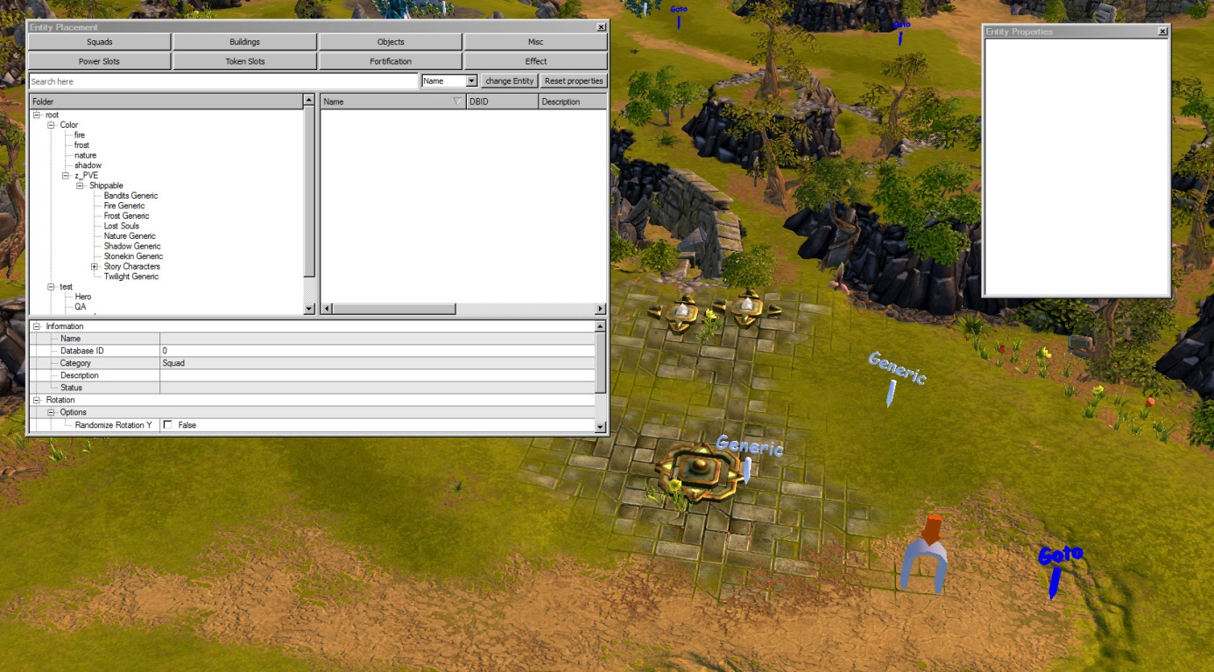
On the left you will see the Entity Placement Window and on the right the Entity Property Window.
First we create a single unit. Choose the button Squads (you have to know that a single units in BattleForge will be called squad too) at the Entity Placement window, than I choose the fraction Frost and pick the Dreadnought Giant.
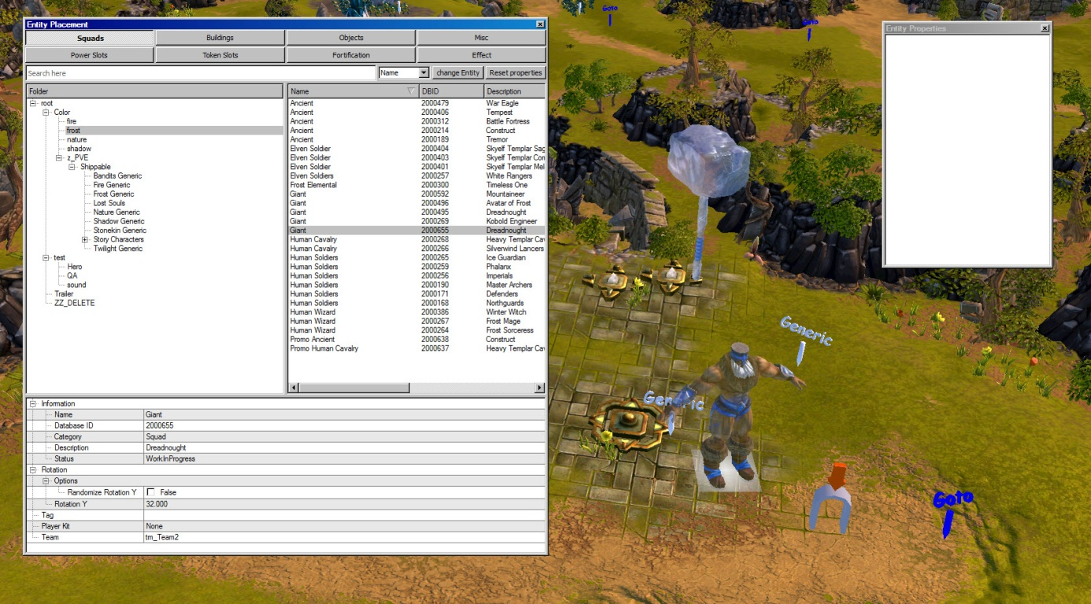
Now the ghost shape of the unit is at my mouse pointer. I choose a nice place to create this entity and push the left mouse button to complete the action.
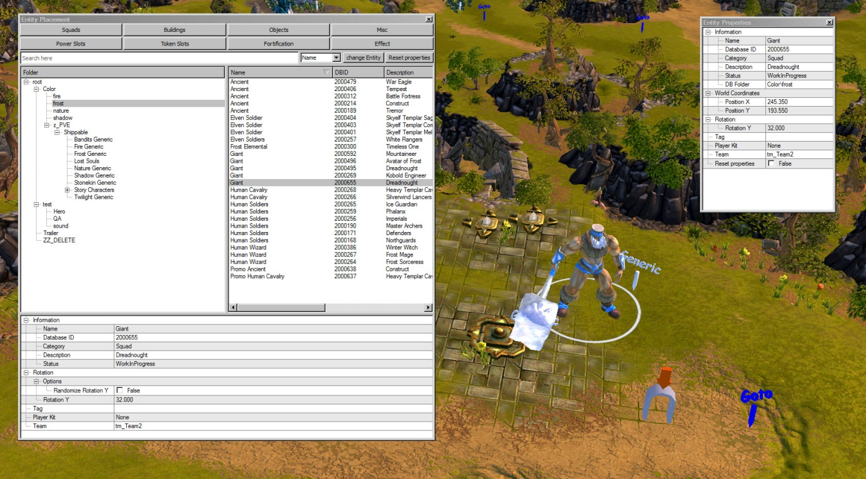
Now I want to give my new Unit a script name (Tag) which I can use later in my script files. In general there are two different ways to do that.
- Enlarge the Entity Placement Window and you will find some parameters below the squad list and before you place a new unit you can write it down there.
- Place your unit first and you will find the same parameters in the Entity property window too.

EXAMPLE:

Here you can read all the database stats of the squad.
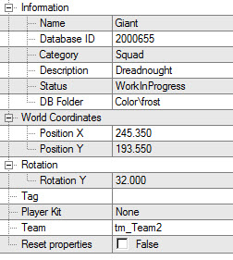
For example the database Identity Number of the squad. The x,y coordinates at the map … look by youself.
When you want to give him now a script name click at the TAG field and write down the name.
I call him “Bernhard”. After that I have to decide if this unit should be played by a human player or by the computer enemy or if he is neutral.
For that I have to choose the right Team and the right Playerkit I have set at the Team Setup Window you will find it under Map Settings/Team Setup & Player Kits in the selection bar.

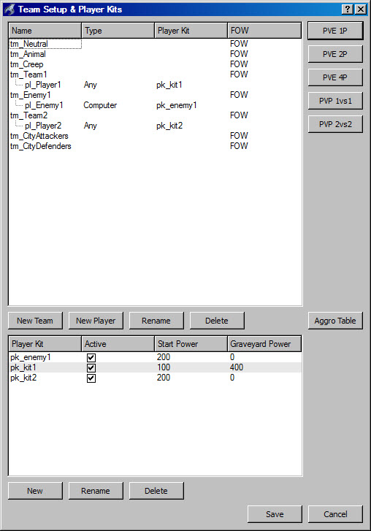
For the human player I have to choose tm_Team1 and Player kit pk_kit1 or tm_Team2 with pk_kit2.
For a computer enemy squad I have to choose the Team tm_Enemy1 with the player kit pk_enemy1.
For a neutral unit I have to choose only the Team tm_Neutral.
Now my Entity Property Window looks like this:
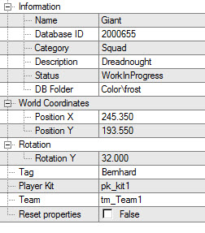
Tutor: „ When you have to set a lot of squads with the same team and player kit settings, it is much more comfortable to set those values in the Entity Placement Window once before you create a squad. Because the Entity Placement Window will save the parameter settings. All squads will be created with these team and player kit settings as long as you do not overwrite them. “

”

Now I want to create an object, a building and a nice effect. The method is exactly the same. For the object and the effect I do not need any team or player kit settings because they are always neutral.
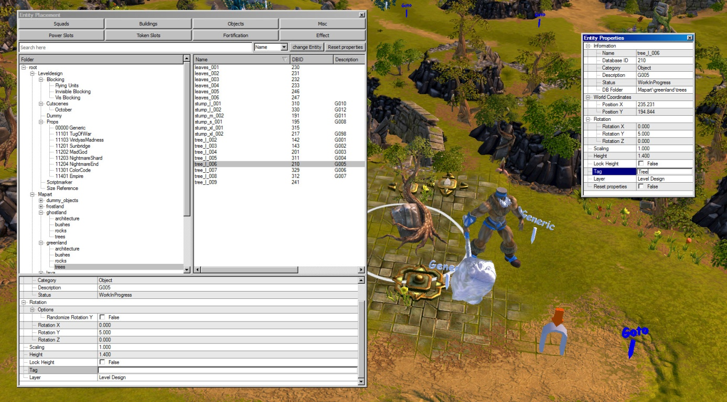
Here I create a Tree (Object). I called it “Tree” and I choose it under Objects/Mapart/Greenland/Trees at the Entity Placement Window.

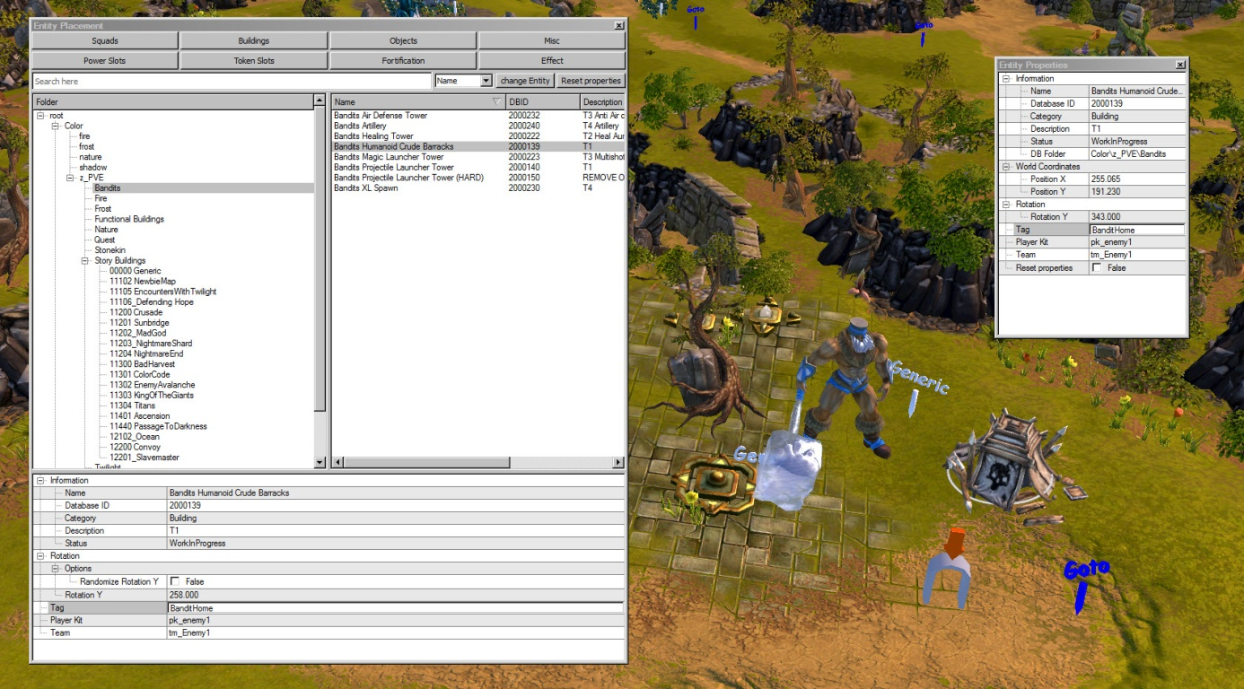
Here I create an enemy bandit building. I called it “BanditHome” and I choose it under Buildings/z_PvE/Bandits at the Entity Placement Window.
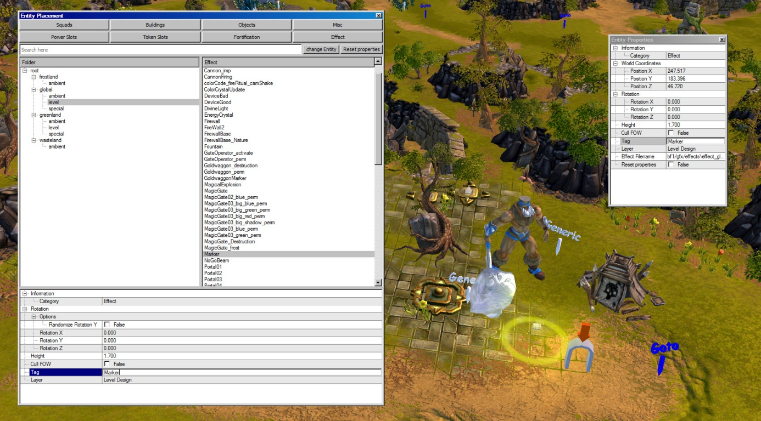
Last but not least, I create an effect and called it “Marker”. I choose it under Effect/global/level at the Entity Placement Window.
Tutor: „ In this chapter you learned how easy you can create entities without scripting. Now you will learn how to do the same by scripting! “

Following you will see five different simple spawn actions.
EXAMPLE:
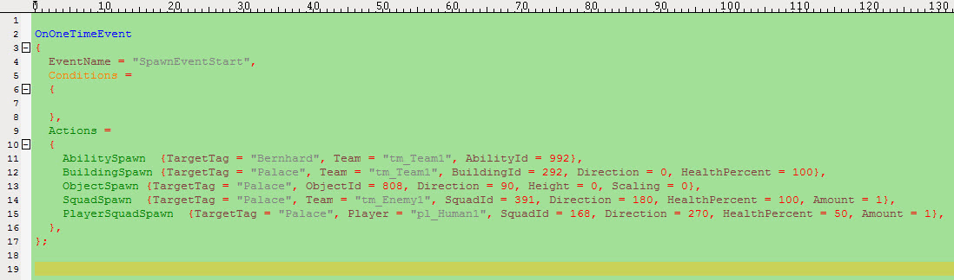
Line11: An Ability with the ID 992 (unkillable) from Team1 will spawn on Entity Bernhard Bernhard will be unkillable.
Line12: A building with the ID 292 (Frost Defense Tower) owning by Team1 with full health will build on place “Palace”. The direction in which the building looks: 0 = south, 90 = east, 180 = north, 270 = west.
Line13: An object with the ID 808 (Fire) will spawn at place “Palace”. Height = default means Object will be placed directly on the ground. 0 = Object will be placed at height level 0 meter. Scaling: Here you can change the scaling, default = 1:1.
Line14: One squad (Amount = 1) with the ID 391 (Bandits) will spawn at target place “Palace” with full health and looking to the north.
Line15: A Frost Defender (Squad ID = 168) will spawn at target place “Palace” owning by Player Human1 with 50% health looking to the west.
An effect you cannot spawn it, but you can start it with this command.

Tutor: „ In this chapter you learned how to create/spawn any kind of entities. Next you will see a spawn command with additional parameters and respawn actions. Mark them well, because you will use them a lot.”

You have the possibility to spawn an entity with an tag. With this command it is very comfortable to control this entity during the game, because you only have to activate the entity tag.

Respawn
You know the OnRespawnEvent, but in BattleFore there are respawn actions for all entities.
EXAMPLE:
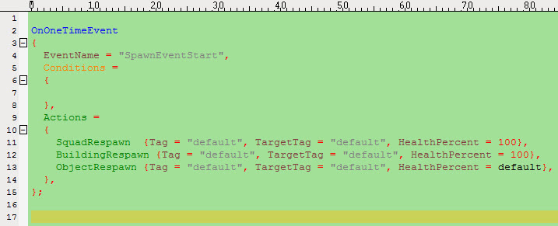
Tag = Script name of the entity which you want to respawn.
Respawn TargetTag allows for two special case-insensitive targets which need not exist on the map:
TargetTag = "StartPos" -- same as empty string "" .. respawn where entity was placed on map
TargetTag = "WhereDied" -- respawn entity where it has died.
HealthPercent is the amount of health the Squad should start with, the default is 100% (full health). Use HealthPercent = DespawnHealthPercent when you want the Squad to have the same amount of healthbefore it was despawned. But use this only if you despawn (vanish) the Squad.
Important: the Squad must be dead respectively all Squads of the ScriptGroup must be dead. Trying to Respawn a Squad that is still alive will cause an error. Always safeguard Respawn with an appropriate "IsAlive" condition! Also, the Squads must have previously existed on the map with the same ScriptTags. To spawn new entities, use the appropriate Spawn actions instead. Respawns a previously existing Squad with the same tag and the same data as before at the position the Squad was initially spawned (usually the location the Squad was placed on the Map). If the Squad's team and owner or other data have changed, Respawn will ensure that the respawned Squad will still have the new data (team, owner, database ID, ...). If something goes "missing" after a Respawn let me know so i can restore this data as well.

Modify Entity
After we create our entity. We want to modify it during the game. For example, make a squad unkillable, set the health of an building to 50%, create an object which casts a spell every 30 seconds, change prisoners from a neutral team to the human player team, change combat Type of an unit from melee to ranged or put a nice effect on an object.
Tutor: „ For the following example use the GDS Help Tool. To search for the conditions and actions and for a better understanding of these commands. ”

EXAMPLE:
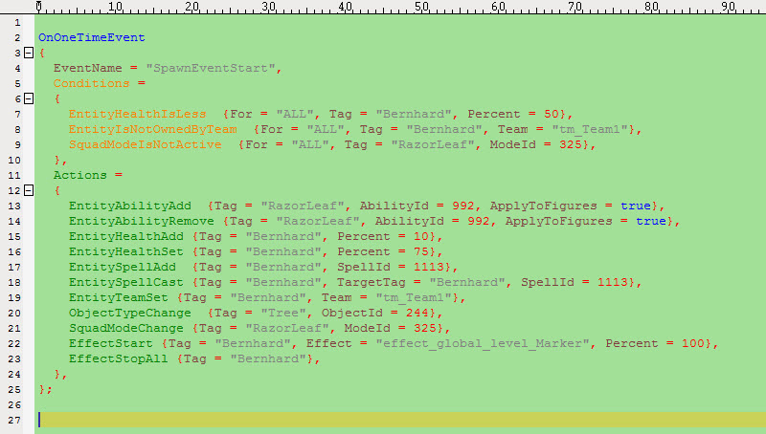
Line 7 Condition: If the Squad with the Script Name (Tag) “Bernhard” has less than 50% of his max Health (Health in the Data Base)
Line 8 Condition: If “Bernhard” is not owned by Team1 (for example in Team2 or in Team Enemy1)
Line 9 Condition: If “RazorLeaf” has not activated the Mode 325 (Ranged Mode, so he should be in Melee Mode).
When all this 3 Conditions are True (remember when there is no other Boolean operant they are AND linked) than the actions will execute once!
Line 13 Action: The Squad with the Script Name “RazorLeaf” and all his squad members (ApplyToFigures = true) will get the Ability Id 992 (unkillable).
Line 14 Action: The Squad with the Script name “RazorLeaf” and all his squad members will lost the unkillable status.
Line 15 Action: The Squad (Single Unit) with the Script Name “Bernhard” will get 10% more Health
Line 16 Action: The health of “Bernhard” will set to 75% (of the Health in the data base)
Line 17 Action: “Bernhard” gets the spell 1113 (Arcane Area Healspell) He will always cast it when the cooldown of the spell is 0.
Line 18 Action: “Bernhard” cast the Arcane spell at himself once.
Line 19 Action: “Bernhard” will be set in Team1 (Human Player). With this command you can switch between the different Teams.
Line 20 Action: The Object “Tree” will be changed into the Object ID 244 (rock).
Line 21 Action: “RazorLeaf” will change íts combat mode from melee to ranged.
Line 22 Action: The Effect “Level_Marker” will be casted on Bernhard with 100 Percent. You will find all Effects in this Folder: D:\project\battleforge\main\redist\bf1\gfx\effects
Line 23 Action: All Effects on Bernhard will be stopped (you will see no more effects).

Tutor: „ In this chapter you learned how to modify existing entities. Remember all of the entities need a script name (Tag). Next you will see how you can move single entities.”

Movement of Single Entities
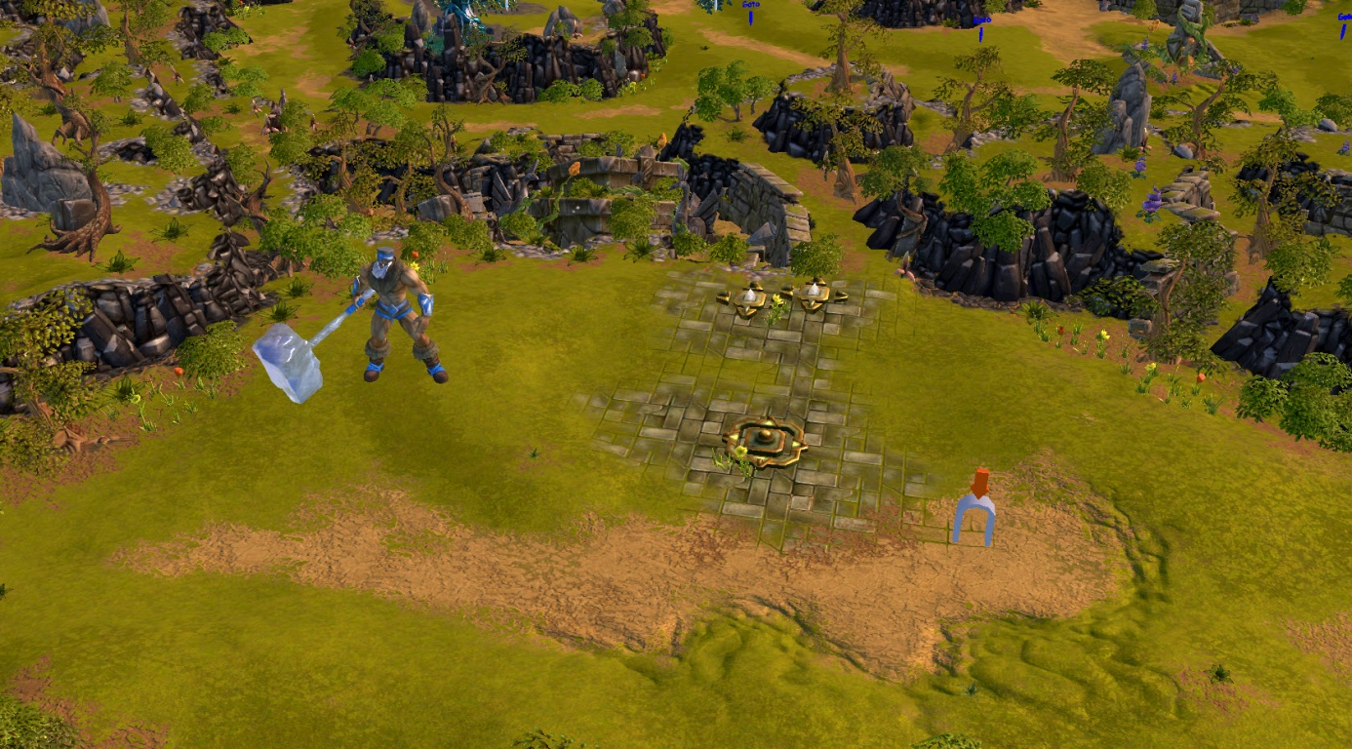
For the first step I need to prepare it in the PlugInBased Editor.
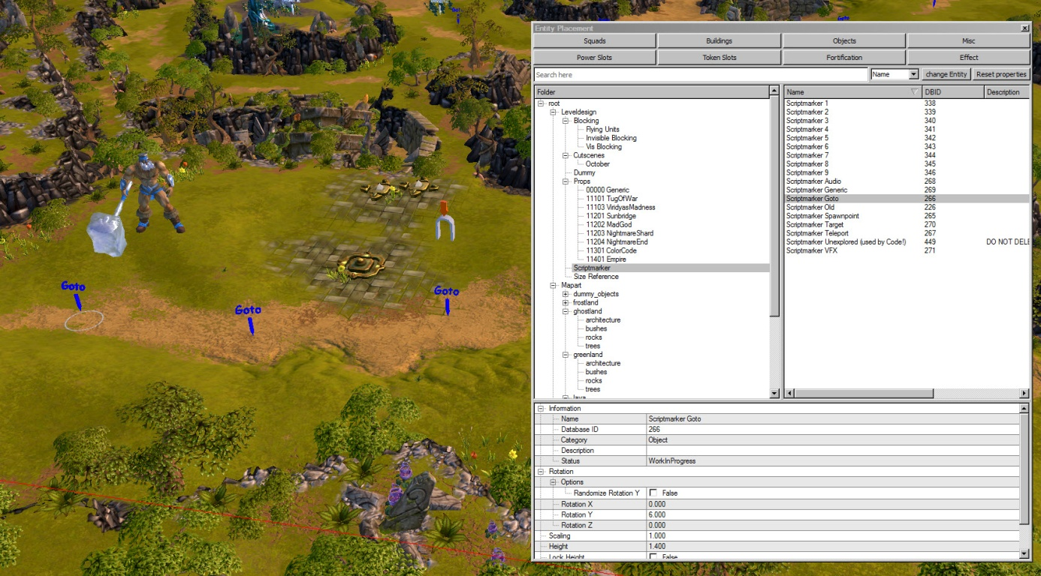
First I create three objects. They called Scriptmarker Goto and you will find them at Objects/Scriptmarker. These objects you won’t see in the game only when you play the BattleForge checked.exe .Then I give them all a Tag “GotoPoint01”, “GotoPoint02” and “GotoPoint03” at the Entity Property Window. After that I placed another scriptmarker it called Scriptmarker Generic and I named it “StartPoint” and placed it near to “Bernhard” the giant.
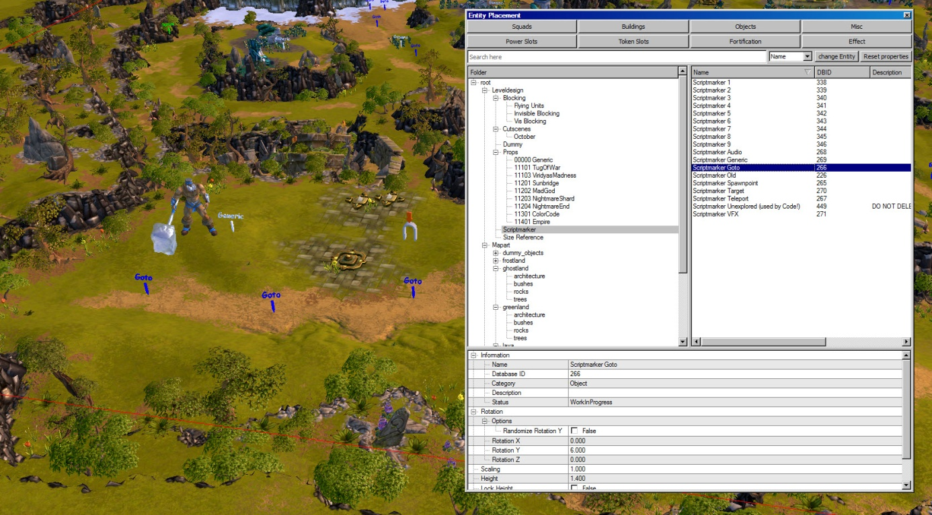
Now I can use following script commands:

EXAMPLE:
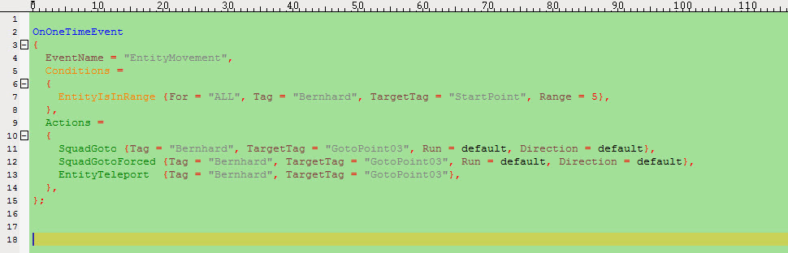
Line 7 Condition: If “Bernhard” is in Range (5 means 5meter radius) to “StartPoint” than the Actions will execute once.
Line 11 Action: Bernhard go to “GotoPoint03” (Run = default because in BattleForge we have only walk, Direction = default because it doesn`t matter because “Bernhard” walks direct to the “GotoPoint03” and changes his direction anyway.
The difference between Line 11 and 12 is that Bernhard will fight against Enemies when he will see them and has left his path for that. With the forced go to he will ignore enemies and walk to his target!
Line 13 Action: “Bernhard will be teleported to “GotoPoint03” it is the fastest move you can script.
Tutor: „ In a real script it doesn’t makes much sense to have these three Actions at the same time. Because “Bernhard” will start to work with the normal goto, shortly after that he uses the forced goto and after that he will teleport. So don’t do that! ”

For the next command you have to create a Script Group (Page 3) in the script group file.
EXAMPLE:
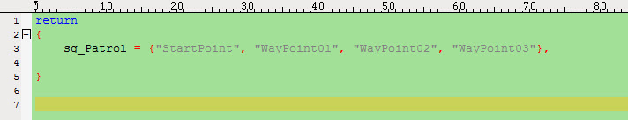
After that you can use the patrol command in the Main or in an Entity script.
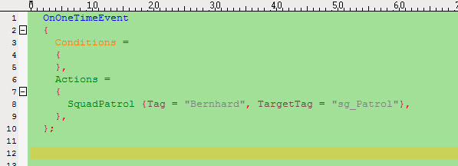
For the last two command you have to prepare your map in the PlugInBased Editor.
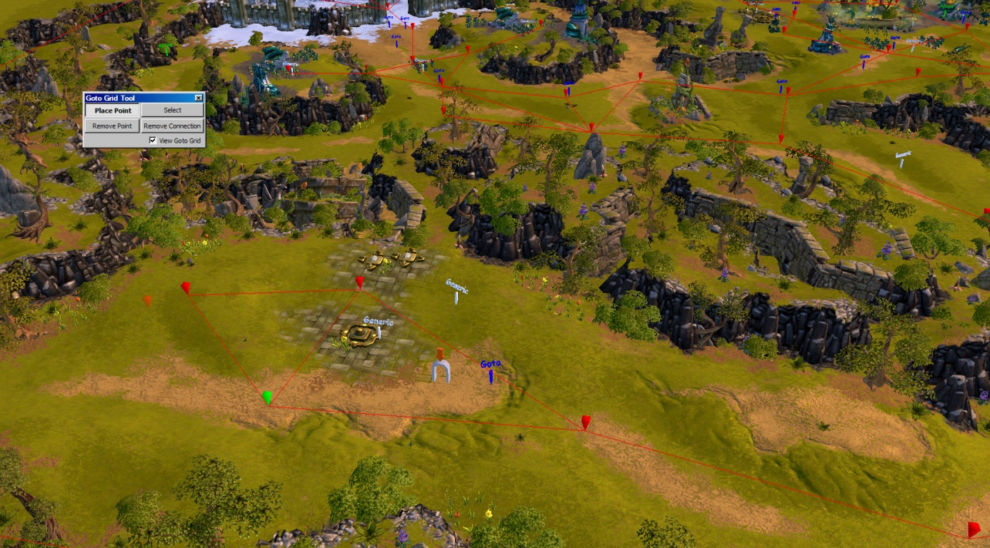
Use the Goto Grid Tool, you will find them in the windows list. Press the button "Place Point". Then click at the left mouse button to place your first point. Hold the button pressed and place the second one. Now release the button and you will see two points which are connected. To link the next point to the second point you have to hold the left mouse button exactly over the second point and release the button at the position of the third point. Carry on with this technique to build a grid over the whole map.
Tutor: „ It is very important to click at the field “View goto grid” otherwise you won’t see any kind of the red path! ”

EXAMPLE:
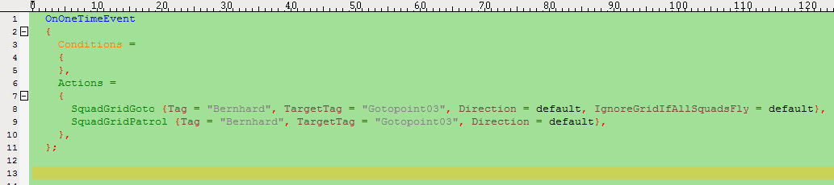
Line 8: Bernhard will go to Gotopoint03 and uses the grid, the direction is default because it will be changed automatically into the direction of the target. IgnoreGridIfAllSquadsFly is default because Bernhard is a nonflying squad/unit.
Line 9: Bernhard is walking between his startpoint and the target Gotopoint03 in a loop.
TargetTag can also be a ScriptGroup or a single Tag. If it's a single Tag then the Squad will patrol from its current location to the TargetTag location and back. If it's a ScriptGroup then the squad will go to the first tag in the ScriptGroup, then to the last tag. So it's not possible to specify waypoints with the ScriptGroup, only the start and end locations. Waypoints will be determined by the Map's GotoGrid between the start and end locations.
There will be another easy way to make simple patrols. Therefore we use the Scripting Tool in the PlugInEditor, you will find the Tool under “Windows” like the Goto Grid Tool too:
EXAMPLE:
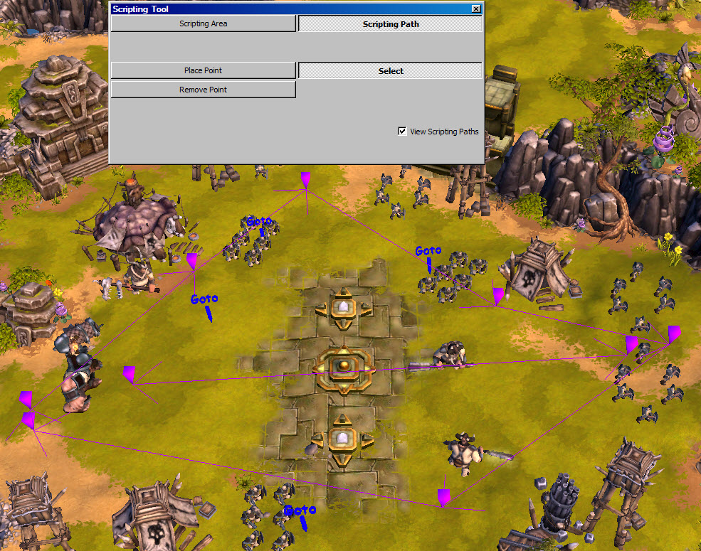
Click at Scripting Path to create a path or Scripting Area to create an area. Use both like the Goto Grid Tool to place combined points. The only difference to the Goto Grid Tool is the color. The Goto Grid is red, the Scripting Path is purple and the Scripting Area is yellow. Important for the Scripting Path and Area is the TAG you have to declare for them. Use the Entity Properties as follow:

EXAMPLE:
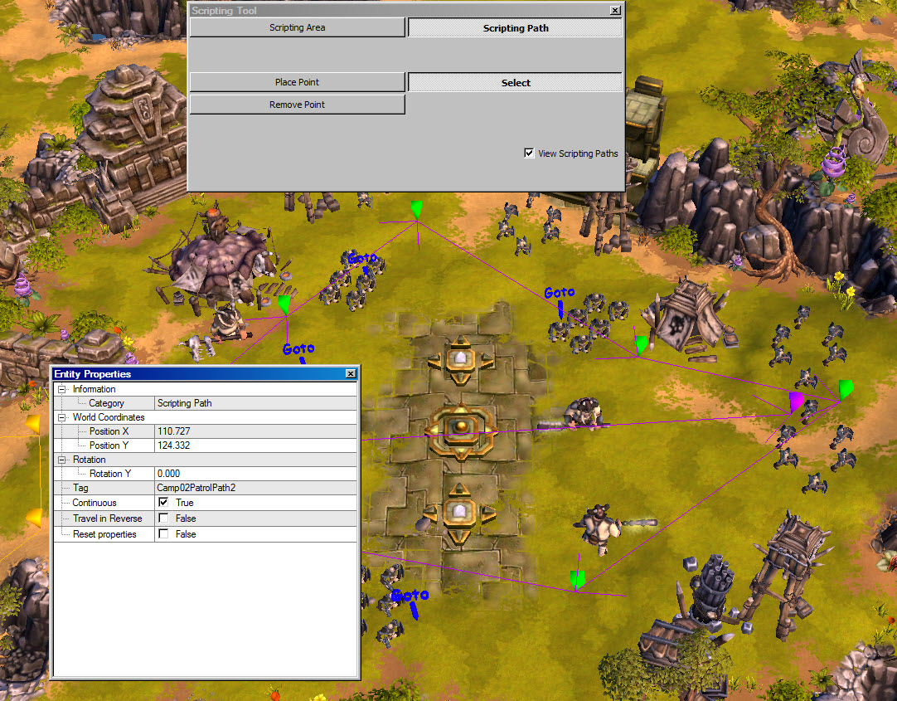
For the Scripting Path you have an additionally parameter, it called “Continuous” and “Travel in Reverse”. With the parameter “Continuous” the patrol squads will loop their patrol way in clockwise direction. With “Travel in Reverse” they will walk counter clockwise.

Now when you will use the Patrol command you only have to type in the correct TAG of the path into the TargetTag parameter.
EXAMPLE:
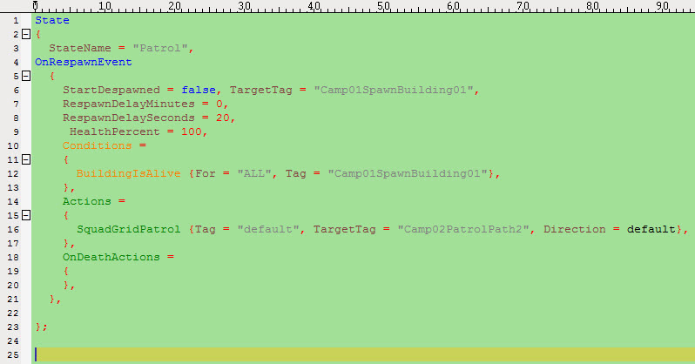

Delete Entities
With the BattleForge script sytem you have following opportunities to delete an entity. It depends which kind of entity you want to delete:
- For units and squads you can use kill or vanish
- For buildings you can use destroy or vanish
- For objects you have to use vanish
- For Abilities you have to use vanish
- For effects you can use stop or vanish
EXAMPLE:
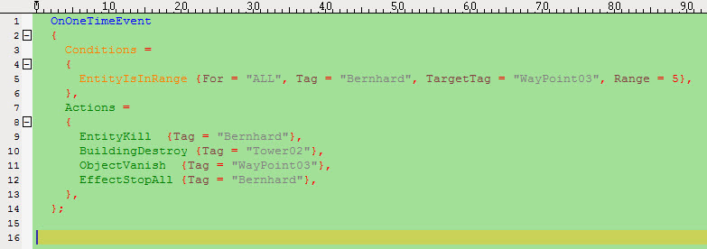

Line 5: After Bernhard has reached WayPoint03
Line 9: He has to die. The die animation will be played and after that the unit will be deleted from the map. When I use vanish the unit will be deleted without the die animation.
Line 10: The Building “Tower02” will be deleted with a destroy animation
Line 11: The Object “WyPoint03” will be deleted
Line 12: All Effects which are linked on Bernhard will be stopped.
Tutor: „ In this chapter you learned every important command to move or delete single entities. In the next chapter you will learn how to handle groups of entities and the warfare pattern. ”

Script Guide for Entity Groups:

Create Entity Groups
You have already learned how to use script groups. So you can use all the scripts for single squads for script groups too, because you only need one tag and for the script groups you can use instead of a single script tag (TAG) the Script Group Tag (for example sg_Guardians) but do not forget the prefix sg_! Spawns squads but additionally add them to the ScriptGroup (parameter "Group"). If that ScriptGroup does not exist it will be created. If it exists and already contains tags, the newly spawned squads will be added to that Group. So be careful with that command. If you only spawn a single squad, then it's scripttag will be the one provided in the Tag = "" parameter. If you spawn more than one squad, the the ScriptTag for each squad will be the Tag = "" parameter plus a consecutive number appended. Eg. if Tag = "mySquad" and Amount = 5 then the squads will get the ScriptTags "mySquad1" through "mySquad5".
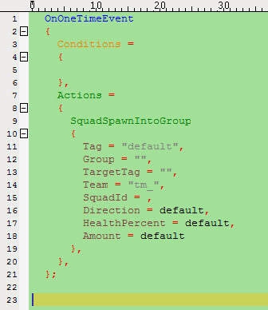
Do not use this command to continuously spawn a huge amount of uniquely named Squads into the same group, this is not a replacement for SpawnWaves! The problem here lies in the fact that each tag added to a ScriptGroup will remain in that group, even if the entity associated with that tag is long gone. So after 1.000 spawns of Squads uniquely tagged "MySquad1" through "MySquad999" the ScriptGroup will contain a thousand tags which are processed by all Conditions using that group. For example, a simple SquadIsAlive with that ScriptGroup would potentially check 1.000 tags wether they are alive. Even skipping the first 990 tags will still cost time and would be a waste of time (performance).
Another very comfortable possibility to spawn huge waves is the WP_SpawnWave Warfarepattern.
Only for this pattern you need a _ScriptGroups file and a single script file with the GroupName of the SpawnWaveEmitter.
In this file you can use following two commands:
EXAMPLE:

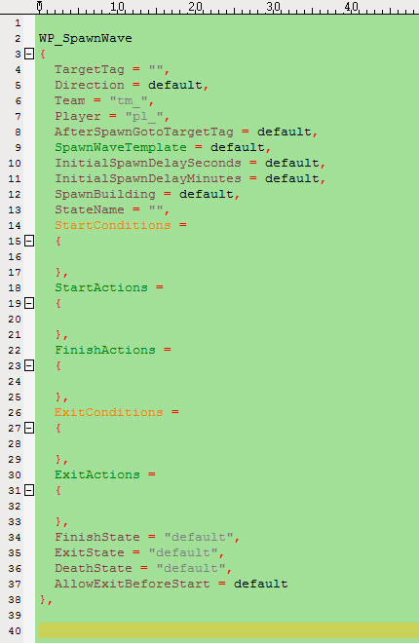
Spawns or respawns waves of Squads as defined in _SpawnGroups.lua
AfterSpawnGotoTargetTag: Use this parameter to let the spawned squads go to a location right after spawning. Intended to avoid that the spawn location is blocked by squads and new squads spawn on the outer "ring" of existing squads. Basically it just looks better when squads move a couple meters after spawn.
SpawnWaveTemplate: Can be used to spawn different SpawnWaveTemplate squads for each WP_SpawnWave.
Overrides the default Template from the SpawnWaveEmitter. Makes it possible to, for example, switch the same wave from spawning infantry to cavalry by using two WP_SpawnWave with appropriate SpawnWaveTemplates.
InitialSpawnDelay…: The delay for the very first spawn of the wave. If 0 wave will begin spawning from the start of the map, otherwise the first Spawn is delayed appropriately and independently from the regular RespawnDelay.
SpawnBuilding: The tag of the SpawnBuilding. If TargetTag is the SpawnBuilding you don't need this parameter. But SpawnBuilding is necessary if you spawn to a TargetTag near the SpawnBuilding but still want the SpawnBuilding to control the spawning (eg. only spawn if it's alive, don't spawn while building is under attack).
EXAMPLE:
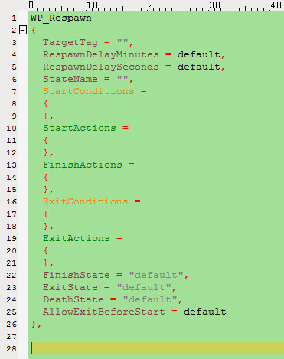

Modify Entity Groups
You have already learned how to use script groups. So you can use all the scripts for single squads for script groups too, because you only need one tag and for the script groups you can use instead of a single script tag (TAG) the Script Group Tag (for example sg_Guardians) but do not forget the prefix sg_! There will be no additional command especially for groups.

Movement Entity Groups
You have already learned how to use script groups. So you can use all the scripts for single squads for script groups too, because you only need one Tag and for the script groups you can use instead of a single script tag (TAG) the Script Group Tag (for example sg_Guardians) but do not forget the prefix sg_! There will be no additional command especially for groups.
EXAMPLE:
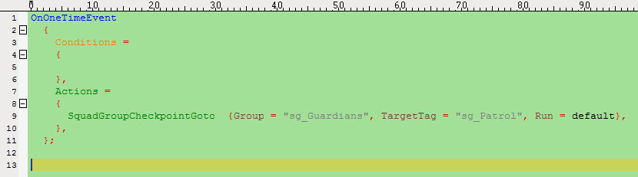
Line 9: The Script group sg_Guardians walk to the Script Group Checkpoints which are set in the sg_Patrol.
This is the new "Polyline" walkmode, eg. the group of Squads walks from checkpoint to checkpoint until the last one is reached. On each checkpoint the squads wait until all squads have arrived to ensure that faster units don't "run away". If there is an obstacle between two points (eg. a Barrier) the squads will move up to the blockade and either stop there until they can get through or they will attack the obstacle.
Checkpoints (TargetTag ScriptGroup) should not be too close together, at least half a screen distance or 15-20 meters is minimum distance between two points but there is no "maximum" distance per se. Instead, as long as between two points there is a clear line of sight you can place them as far away as you need. And the "line of sight" is only a recommendation because that is supposed to be better for performance if the squads can "see" the next point from the current point. Note: Group parameter must be a ScriptGroup! If you only want to send a single squad to some location there is no need for it to wait for "others" and so you should use the "SquadCheckpointGoto" instead.
The next command is a warfare pattern. For this pattern you need a _ScriptGroups file and a single script file with the GroupName of the SpawnWaveEmitter.
In this file you can use following command:

EXAMPLE

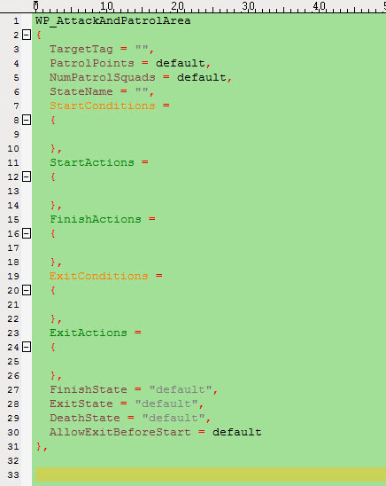
Sends the ScriptGroup of squads to the "TargetTag" location. TargetTag should be a single script tag. If you want to (initially) send the Group along a path towards the TargetTag, rather than the TargetTag directly, simply use a SquadGoto command in the StartActions with the path as TargetTags of the Goto command.
PatrolPoints is a ScriptGroup of points the squads will patrol.

Tutor: „ In this chapter you learned every important command to spawn/respawn or move entity groups. Remember that you can use all the commands for single entities too. You only have to create a script group and use the script group tag instead of a single tag. You learned also our three warfare pattern, WP_SpawnWave, WP_Respawn WP_AttackAndPatrolArea. ”

User Interface in BattleForge

Missiontasks, -counters and –timer

Tutor: „ In this chapter you will learn everything about our visual Missiongoals . ”

To lead the player we have following UI-objects
- Missiontask
- Missioncounter
- Missiontimer
You can use following commands:
EXAMPLE:
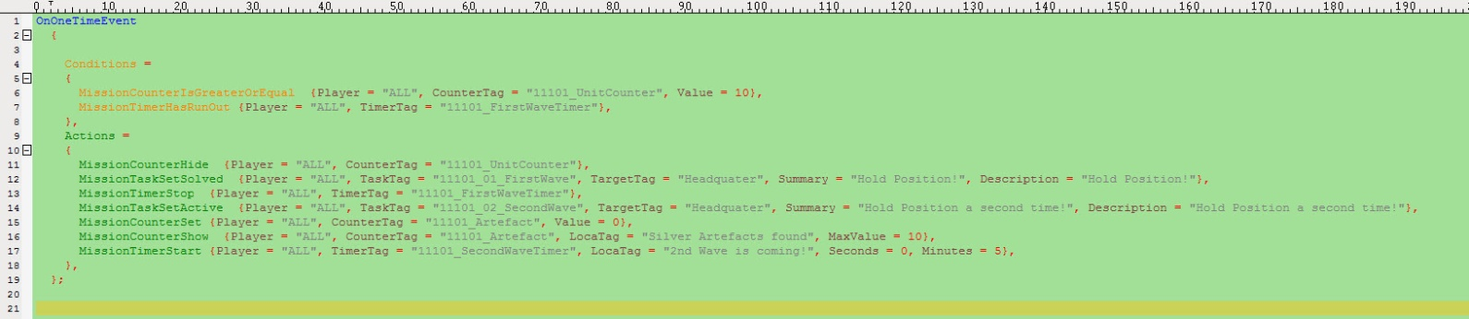
Line 6 Condition: Is the counter “11101_UnitCounter” greater or equal 10?
Line 7 Condition: And is the MissionTimer “11101_FirstWaveTimer” run out?
Line 11 Action: Hide Mission Counter “11101_UnitCounter”
Line 12 Action: Mission Task “11101_01_FirstWave” set solved
Line 13 Action: Stop Mission Timer “11101_FirstWaveTimer”
Line 14 Action: New Mission Task “11101_02_SecondWave” set active
Line 15 Action: New Mission Counter “11101_Artefact” set to 0
Line 16 Action: Show Mission Counter (UI) “11101_Artefact”
Line 17 Action: Start new Mission Timer “11101_SecondWaveTimer” with 5 min.
The player will see following UI at the top of his BattleForge Screen:
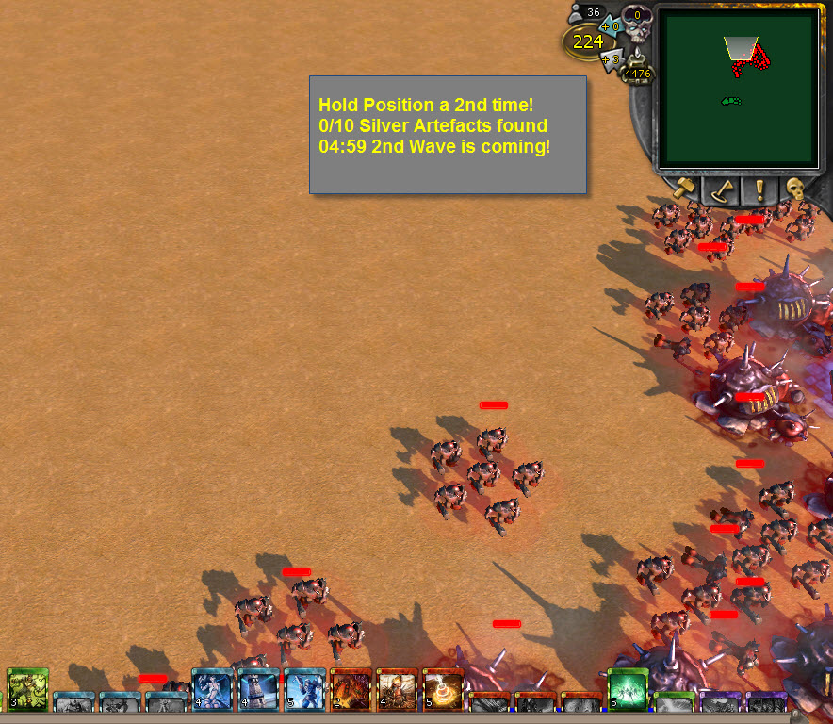
Tutor: „ In this chapter you have learned how to use the visual UI commands for the Player goals. Next you will learn everything about the balancing. ”

Balancing in BattleForge
In BattleForge we have 5 tiers and 2 upgrade steps each card.
Tier 1 weak Tier 5 strong
Upgrade step 0 weak Upgrade step 2 strong
We have following player standards on our maps. At map start each player own at least one monument/token and two power slots (600PvE/900PvE) and they are starting with 100 Starting Power and 200 Graveyard Power. You can adjust this in the Map Settings/Team Setup & Player Kits in the PlugInBased Editor.
EXAMPLE:
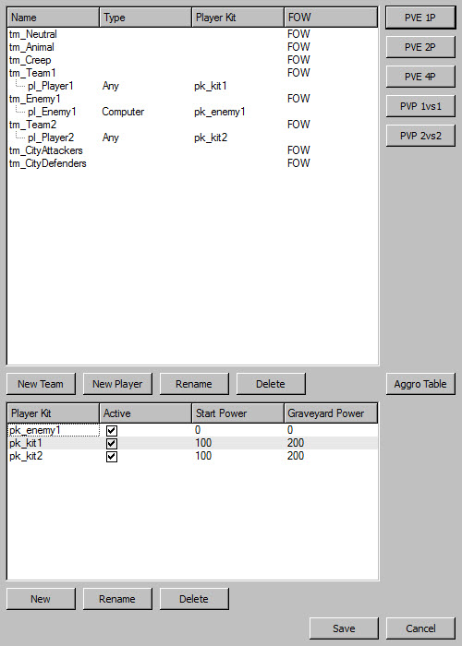

For the Scripting you have following opportunities
- Using a condition
- Using a difficulty single script file

Using a condition
EXAMPLE:
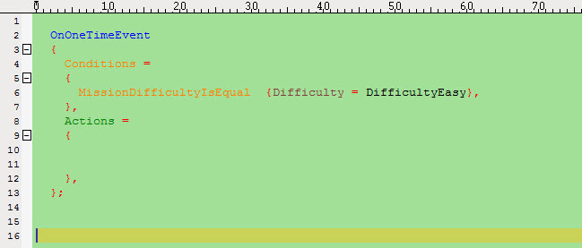
Line 6: If the difficulty is == easy (Standard) the actions will be executed
Tutor: „ Please remember always:
easy = standard config.lua ==1
normal = advanced config.lua==2
hard = expert config.lua==3!”

Using a difficulty single script file
EXAMPLE:
Line 1: Lua if, then script command
Line 2: New state starts but only when the difficulty is easy (Standard)
Line 12: When the difficulty is easy (Standard) the heavy unit “spikeroot_e2” will be vanished from the map.
Line 19: The Lua if, then command ends (Don’t forget this!)
You can use the script file for all three difficulties. You only have to make three states with three different conditions. Start with the next difficulty below Line 20.
Tutor: „ Now I show you everything I can remember. Hopefully it is enough to script wonderful PvE BattleForge maps! Use your time to make some test scripts to learn the commands and their effects. ”

